Retesting defects:

Defect 1:

Temple management>> Darshan>> after clicking on Confirm booking here it is displaying like processing and no request is displaying in the POS machine & displaying same page without getting any error.

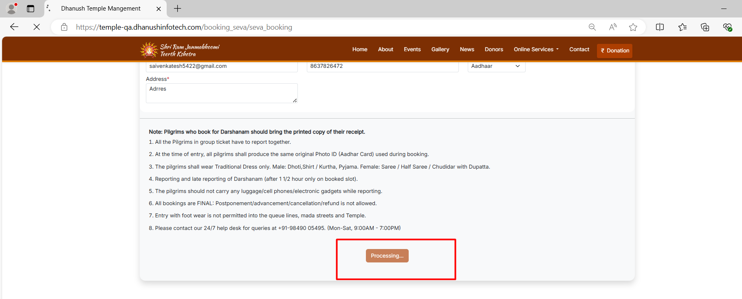

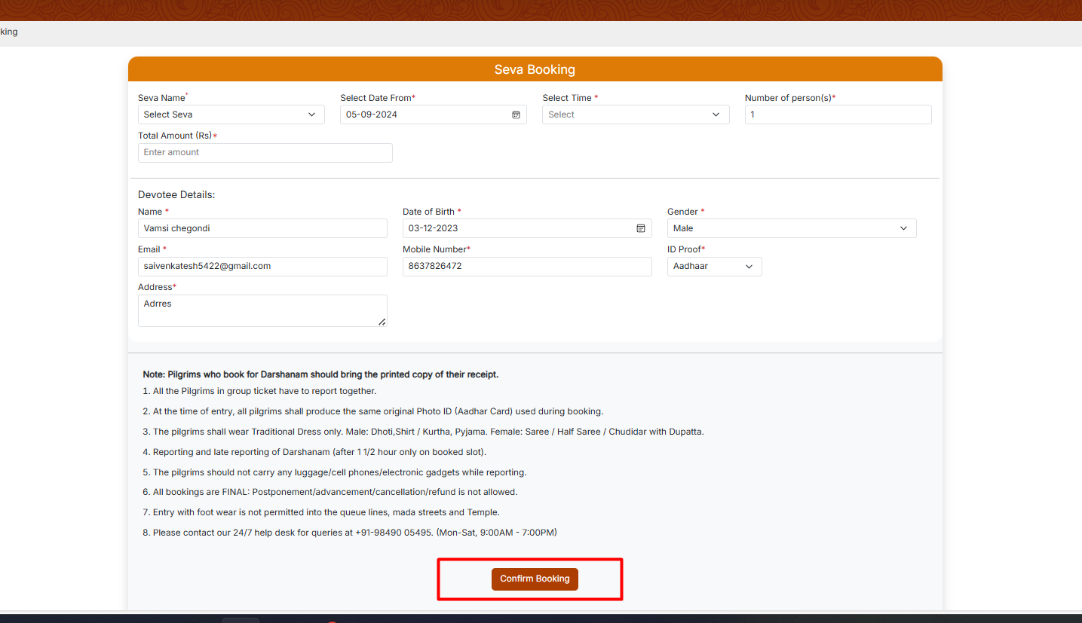

Defect 2:

**Defect 9 in QA instance issues**>> Temple management>> All bookings>> clicking on download button here an uncaught exception occurred error alert is displayed. Please refer screenshot.

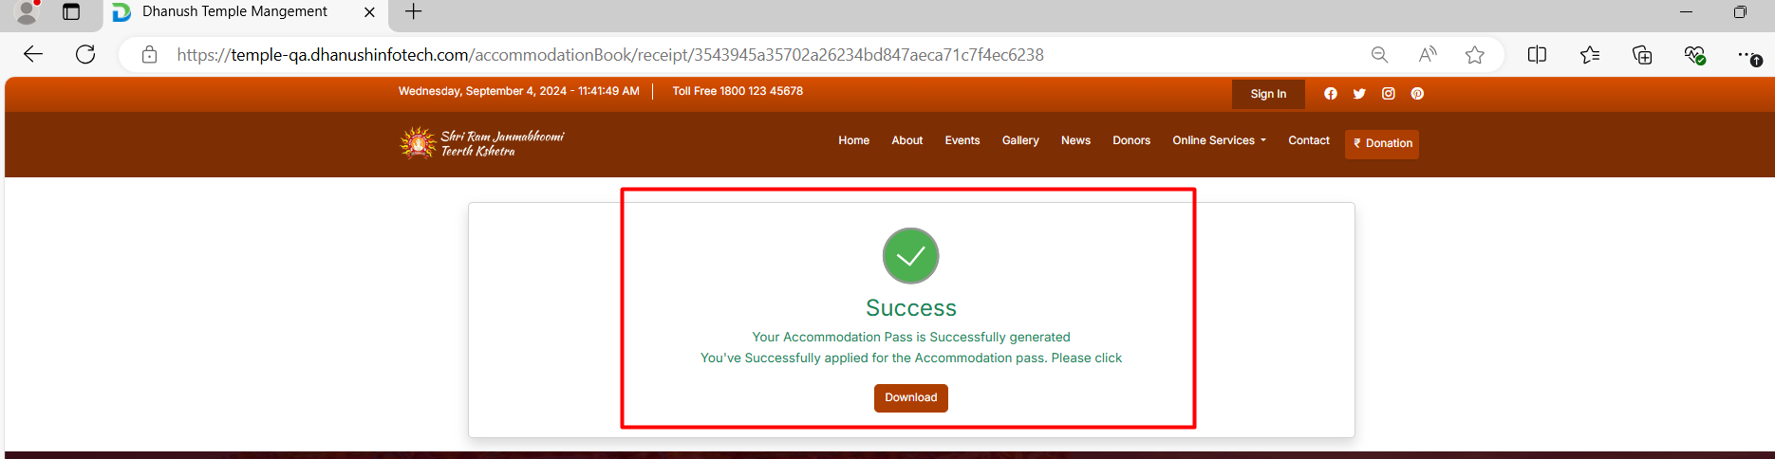

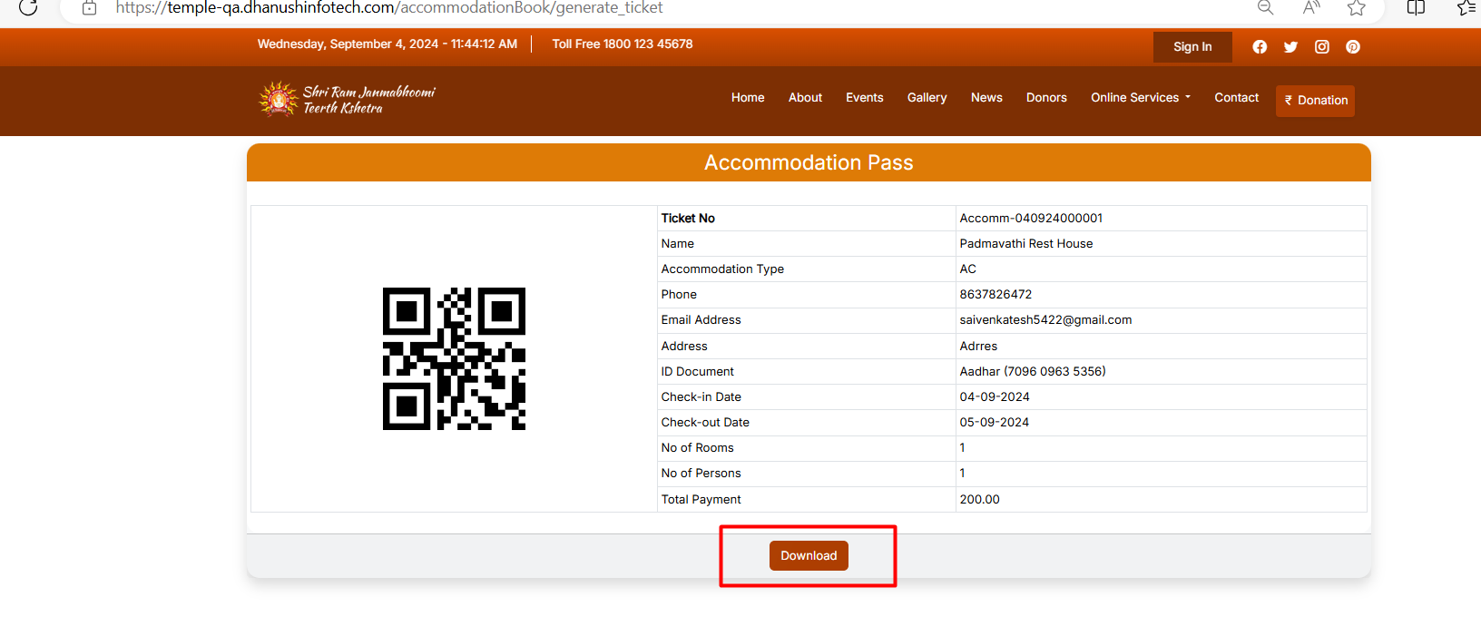

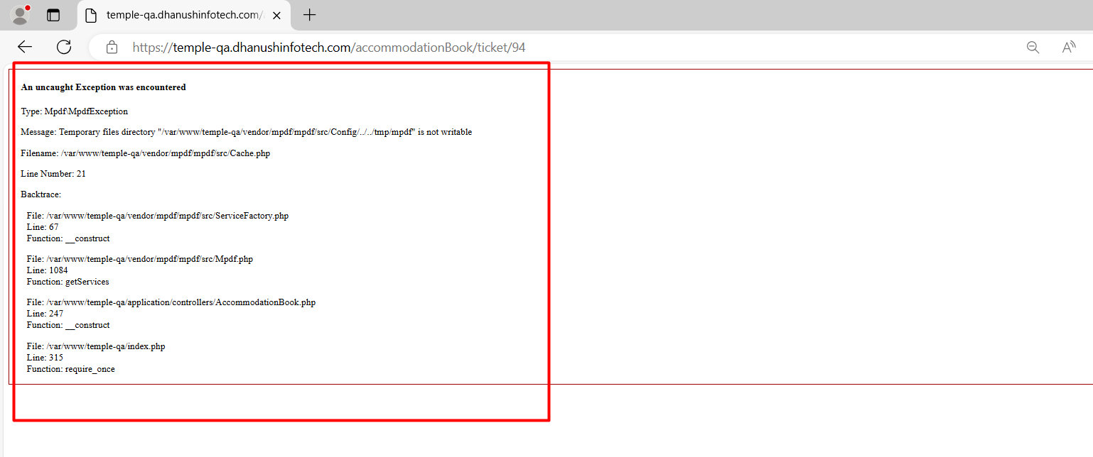

Defect 3:

**Defect 13 in QA instance**>> Temple administration>> Donation>> Here in the Aadhaar no field alphabets are accepting it should not acceptable.

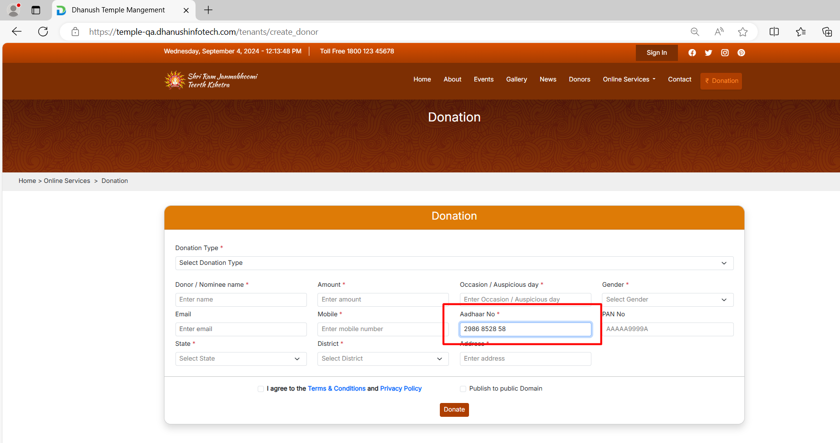

Defect 4:

**Defect 15 in QA instance>>** Temple management>> donation>> Selecting all fields and adding wrong details & clicking on donate button here it is not showing any alert and again displaying blank fields, Please refer screenshot.

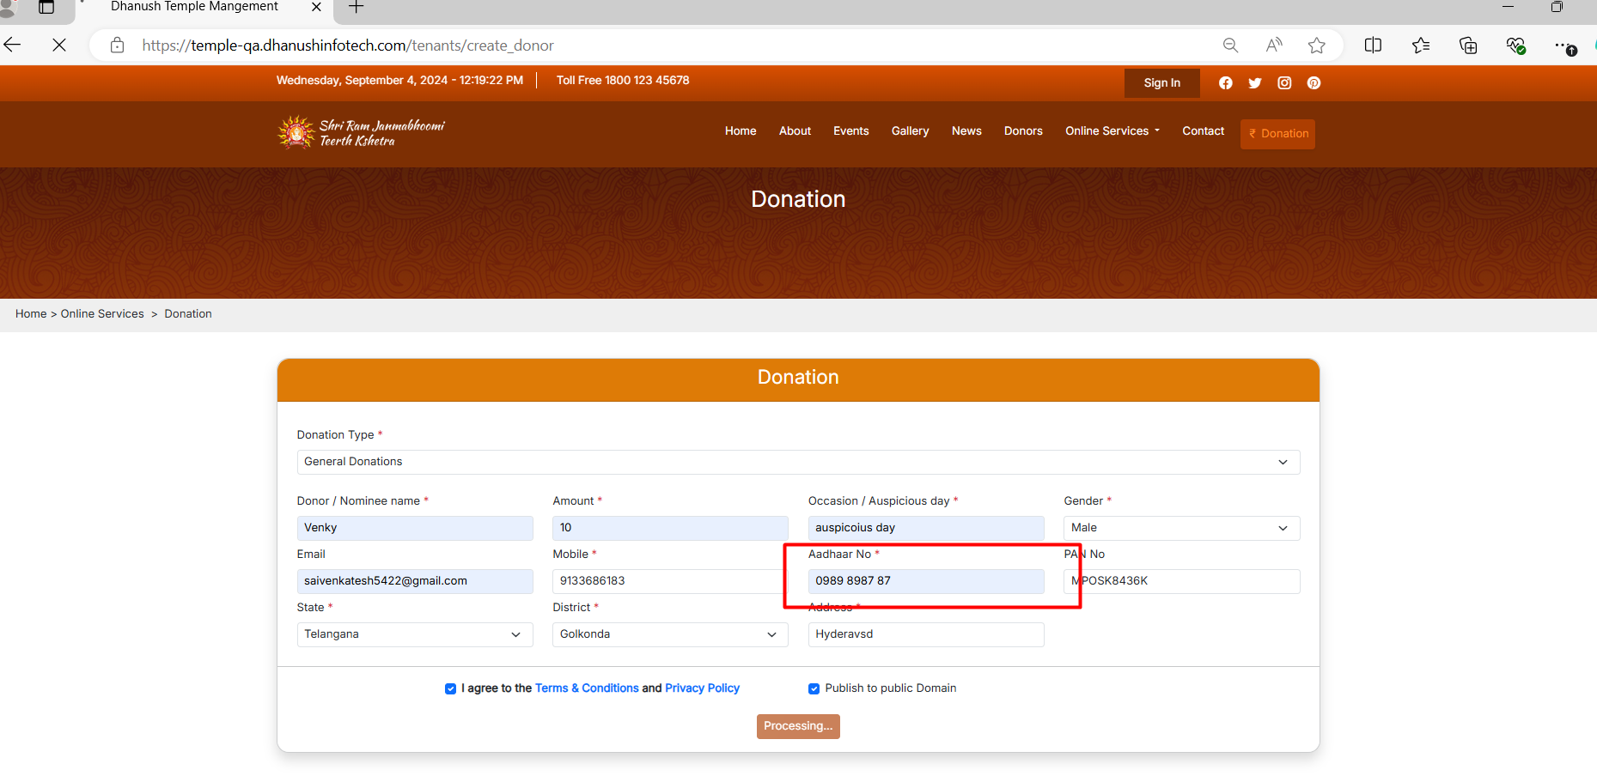

Defect 5:

**Defect 17 in QA instance>>** Temple management>> Time based Donation>> Entering all fields with valid data and clicking on donate button here that functionality is not working.

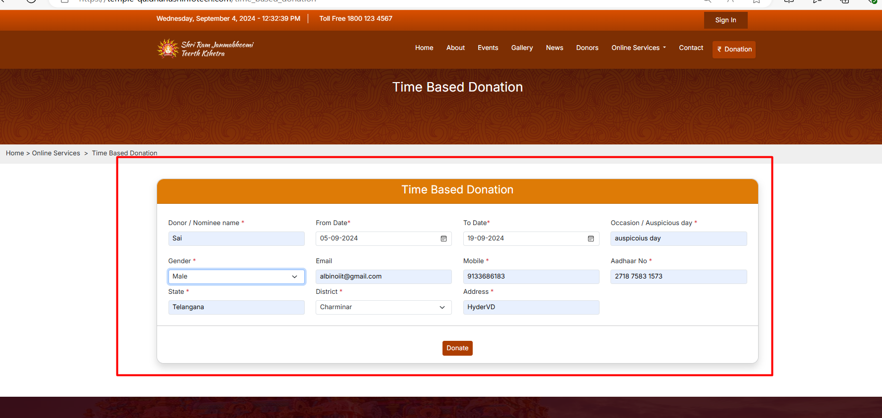

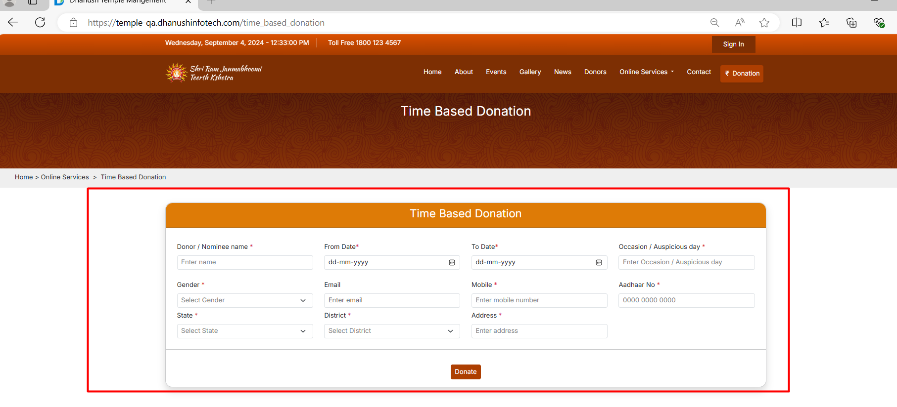

Defect 6:

**Defect 18 in QA instance>>** Temple management>> Admin>> Created one seva and submit but that seva slot is not displaying in any seva booking page please refer screenshot.

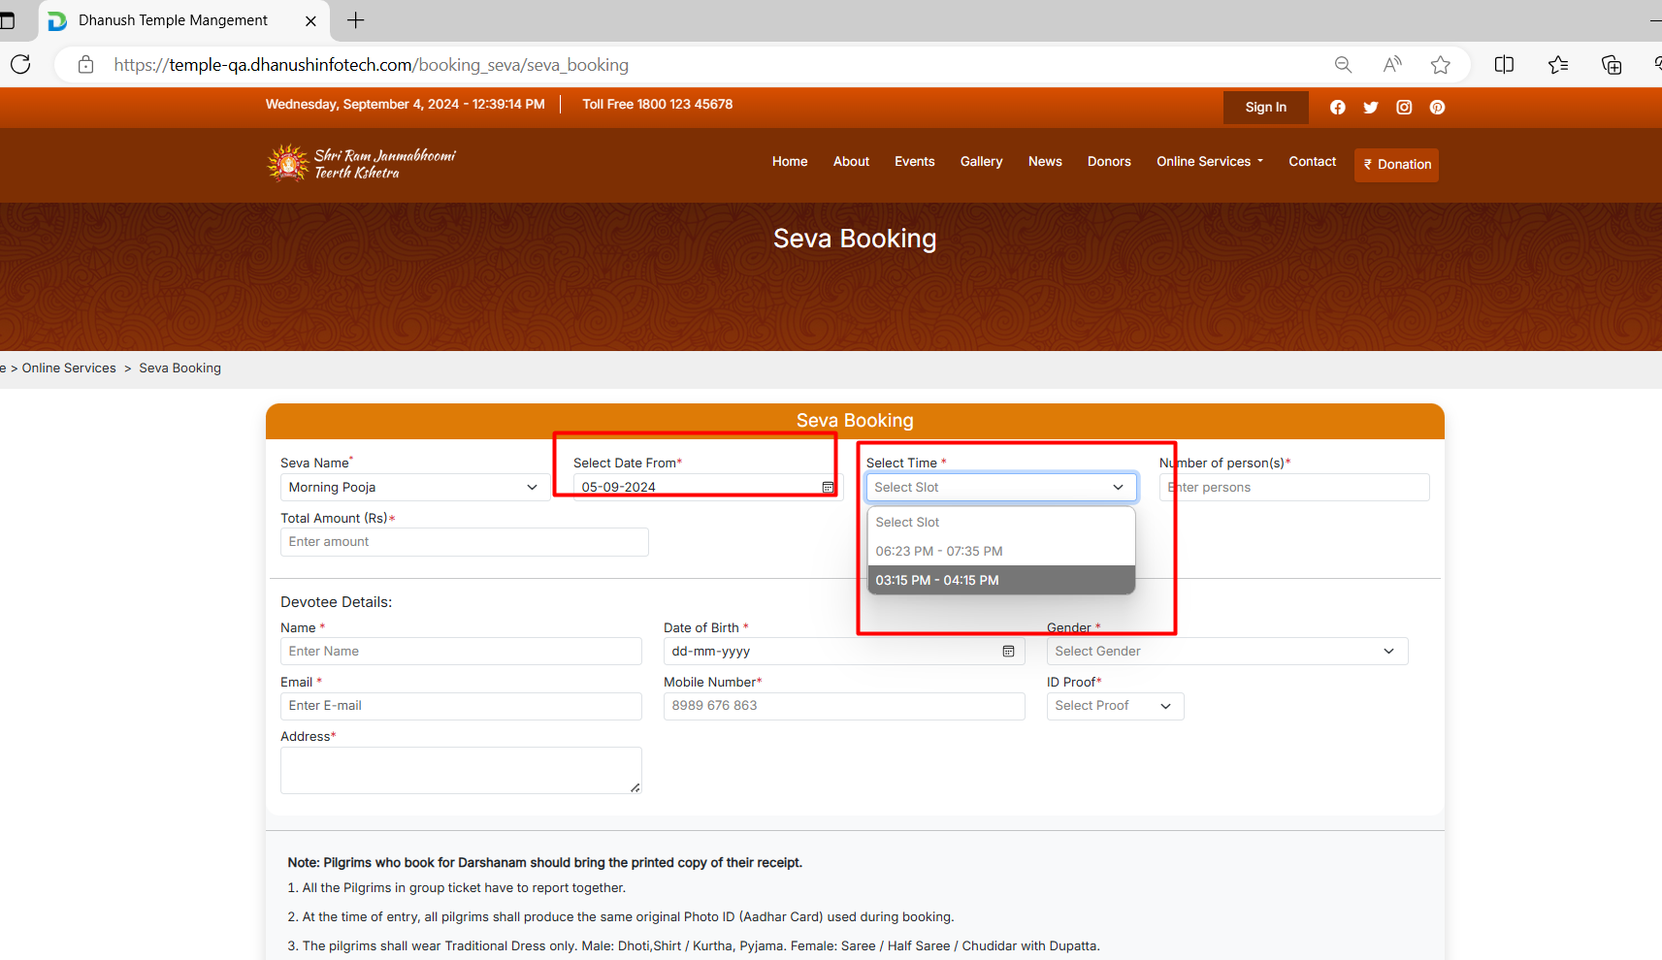

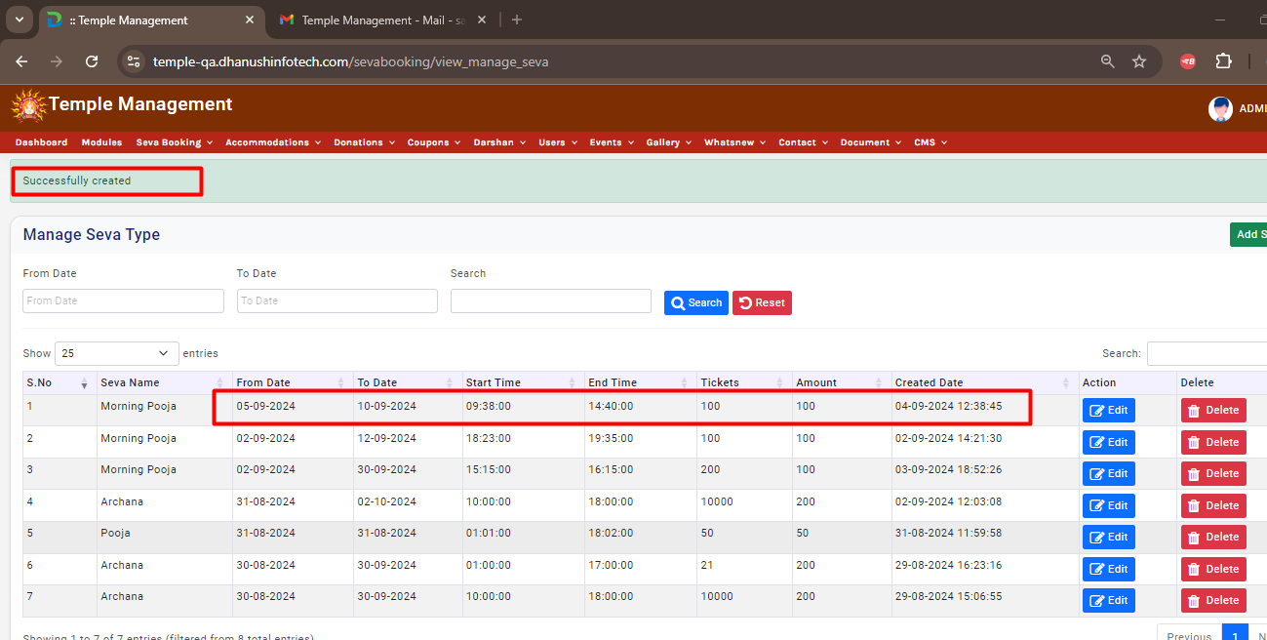

Defect 7:

**Defect 18 in QA instance>>** Temple management>> Counter login>> Accommodation details>> Selecting card and entered all fields and clicking on confirm booking here without doing POS transaction here booking confined alert is displaying

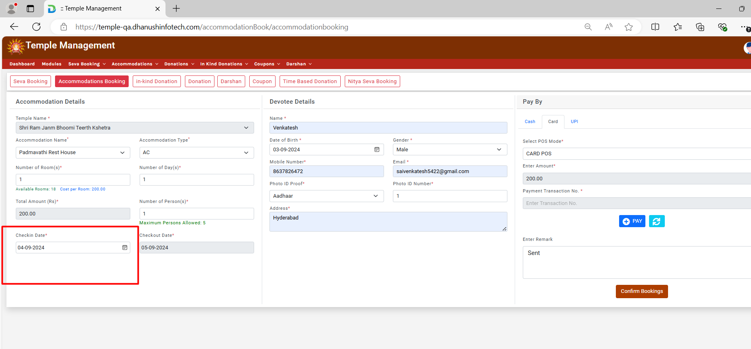

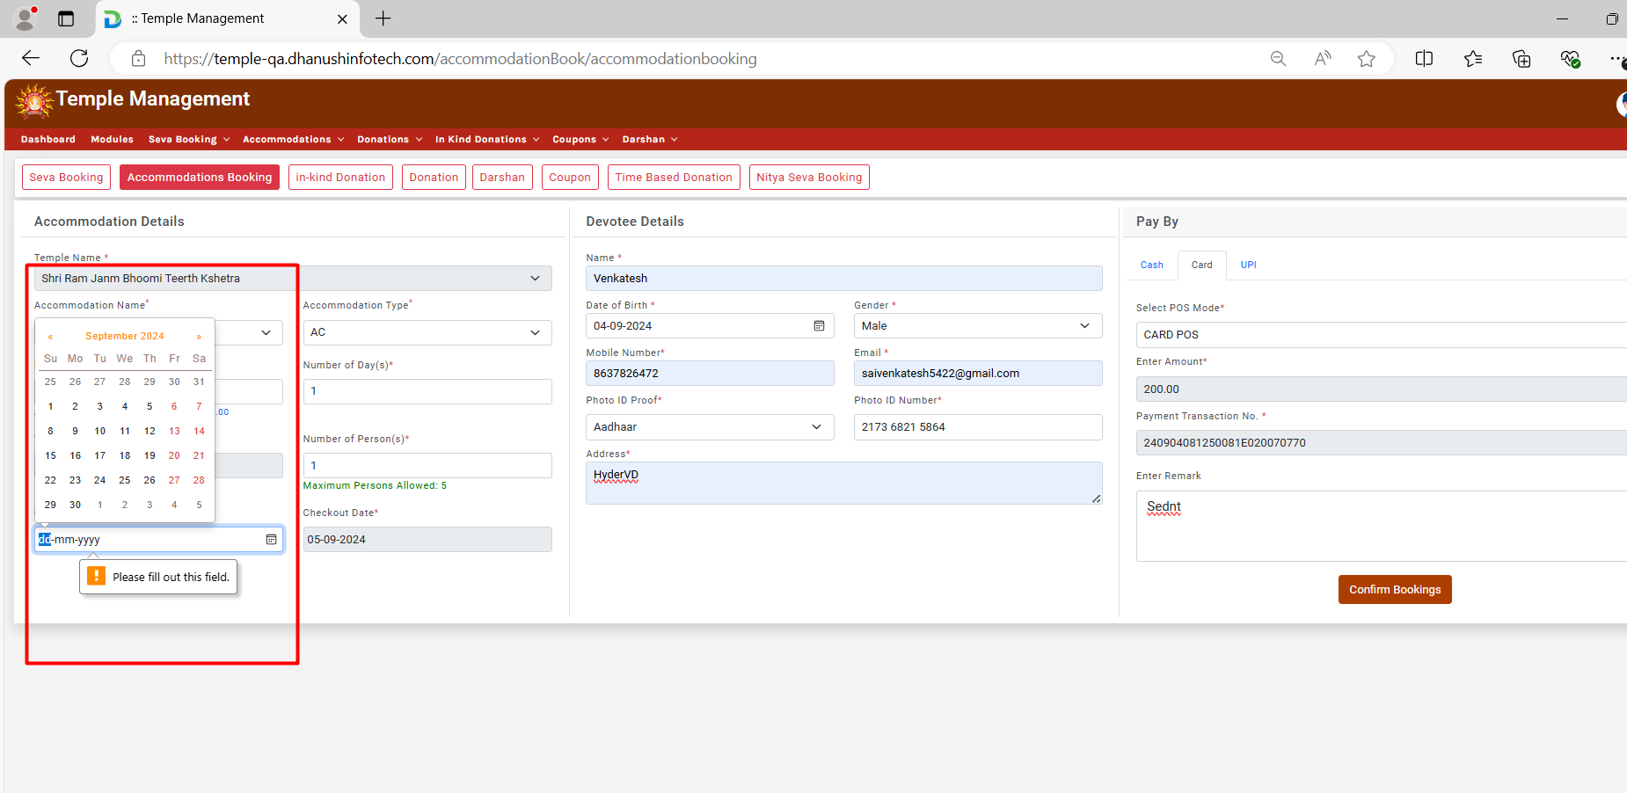

Defect 8:

Temple management>> Counter login>> Darshan booking>> Here in this page unwanted test is displaying please refer screenshot.

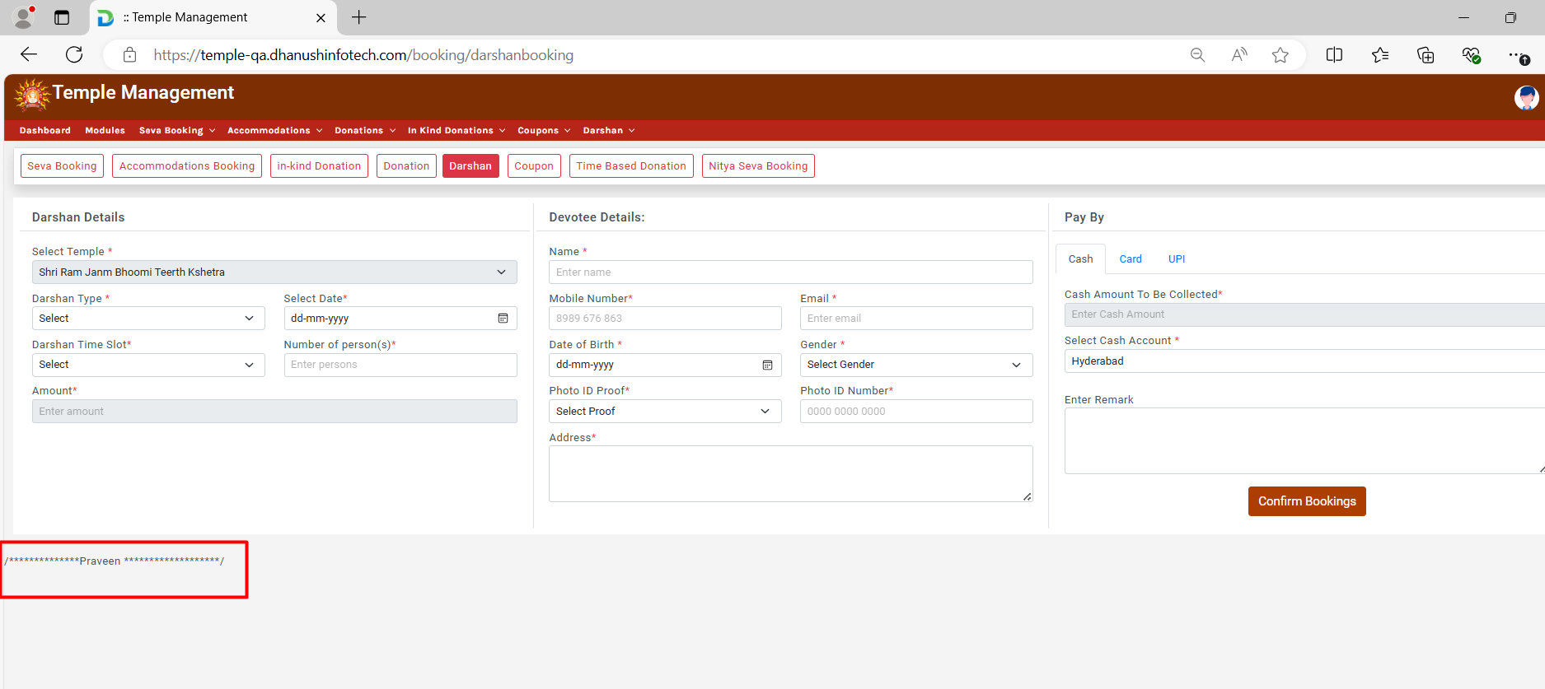

Defect 9:

**Defect 23 in QA instance>>** Temple management>> Counter login>> Darshan booking>> Gere in the admin access free darshan contains slots and but here in the booking of darshan no slots are displaying please refer screenshot.

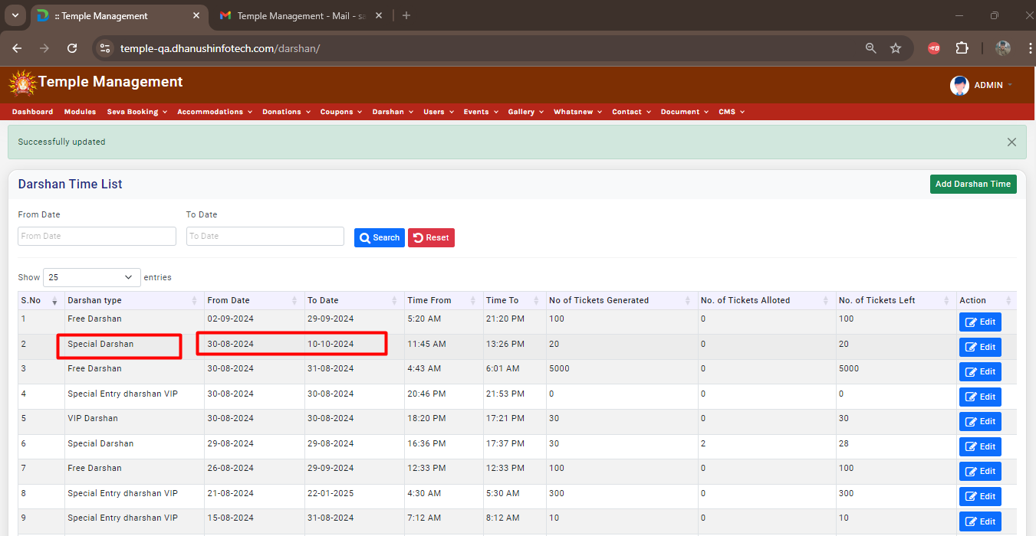

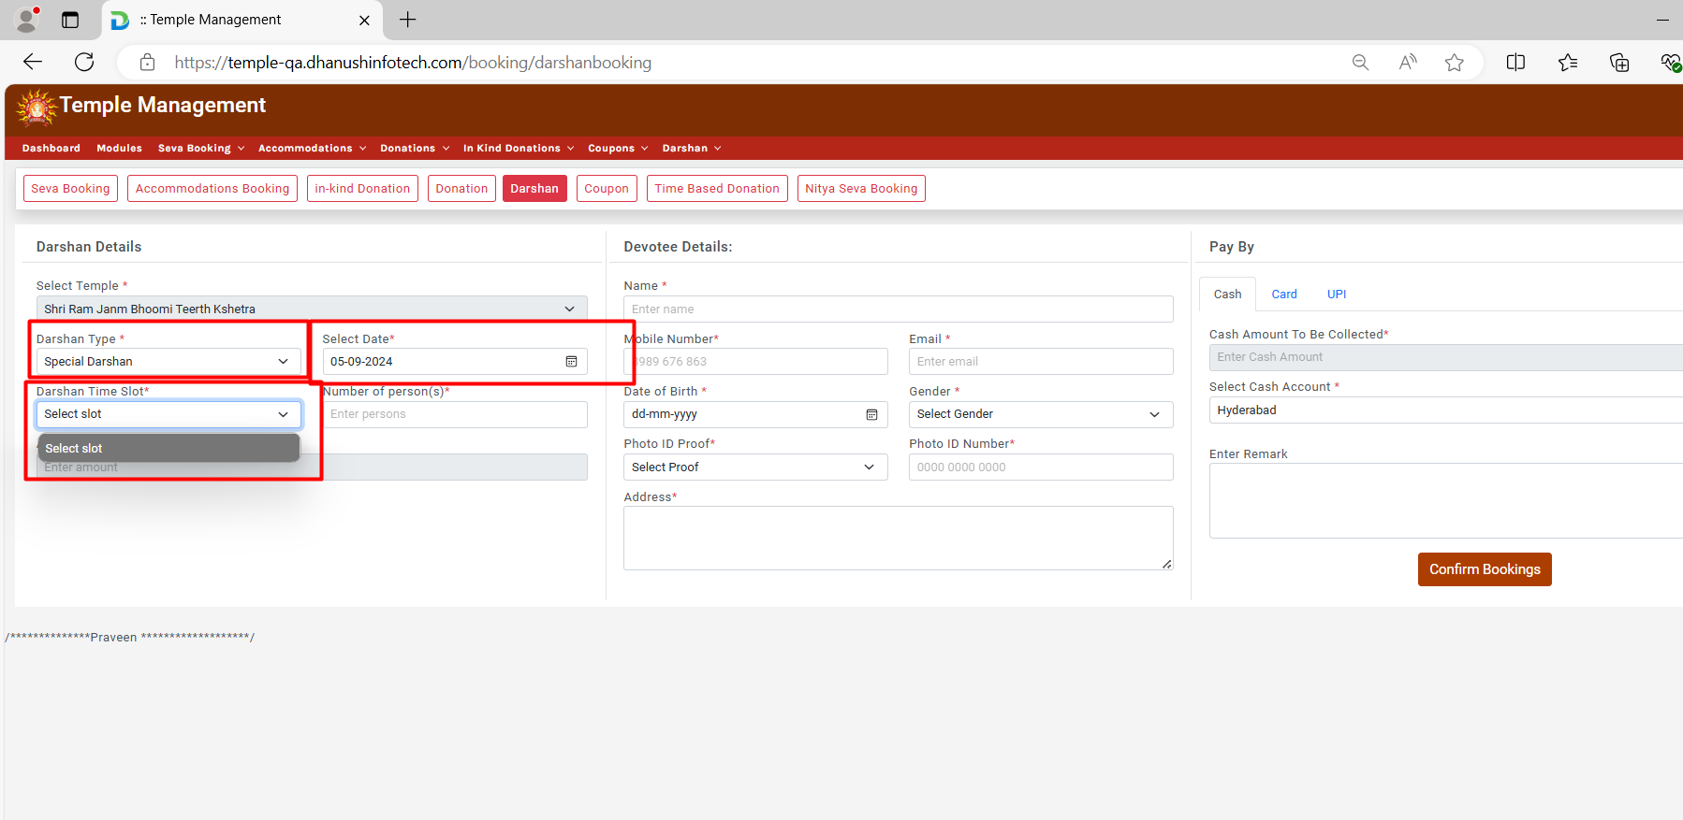

Defect 10:  
**Defect 34 in QA instance>>** Temple management>> Admin>> Time based donation>> Clicking on approved, approval mail is not getting to the user please refer screenshot.

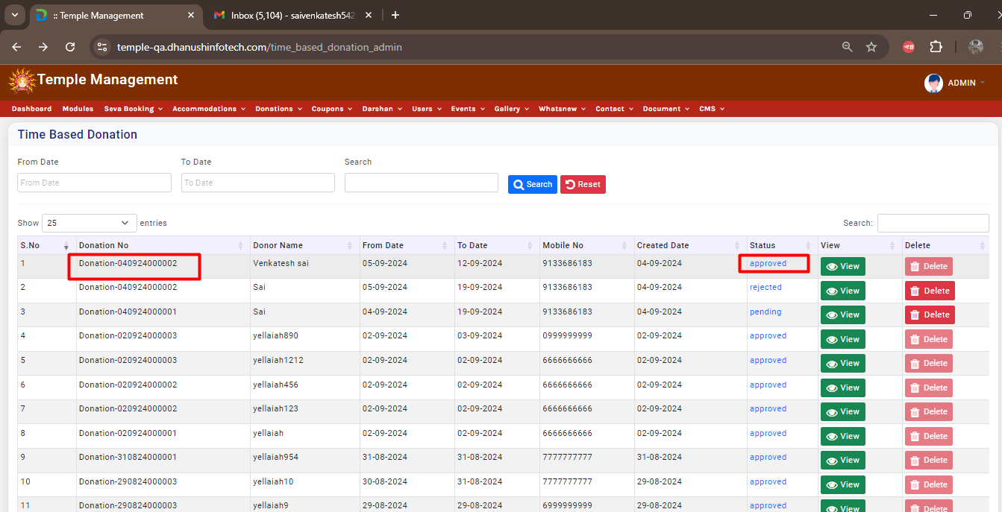

Defect 11:  
Temple management>> Admin>> Create event>> Here in event start time alignment is not proper after selecting time, please refer screenshot.

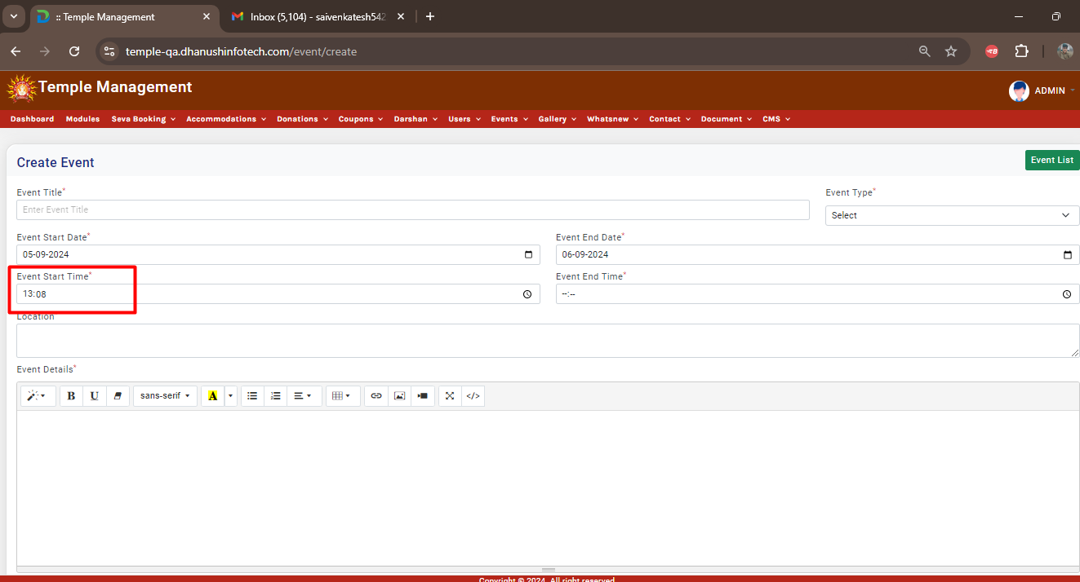

Defect 12:

Temple management>> Admin>> Create event>> Here in the upload resume does not contains mandatory but here it is asking.

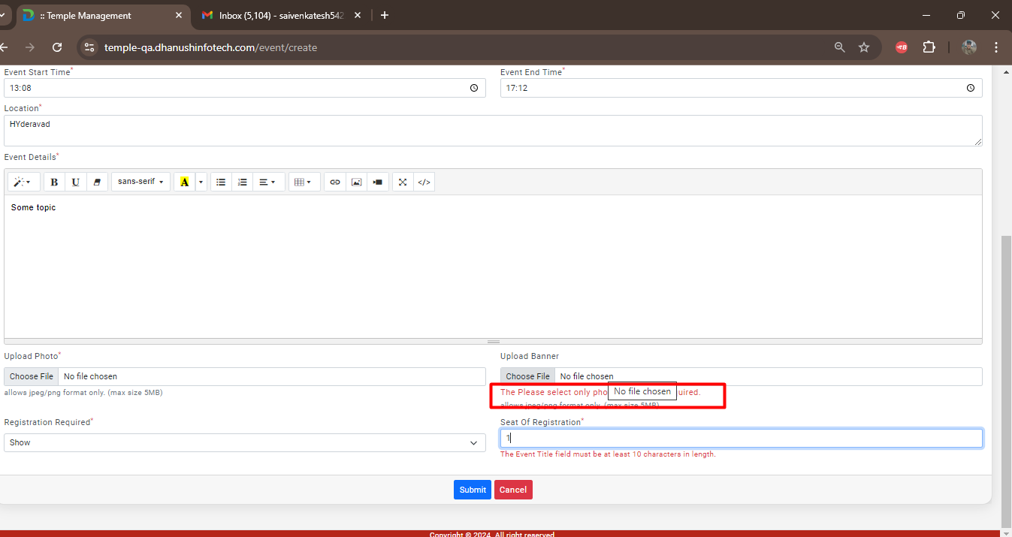

Defect 13:

Temple management>> Admin>> Create event>> Here for seat of registration and title getting same alerts please refer screenshot.

