**NCST ADMIN Issues:**

**Date: 29/05/2024**

1. Web>>Admin>>Users>>In line-list, Duplicate Label names are displaying.

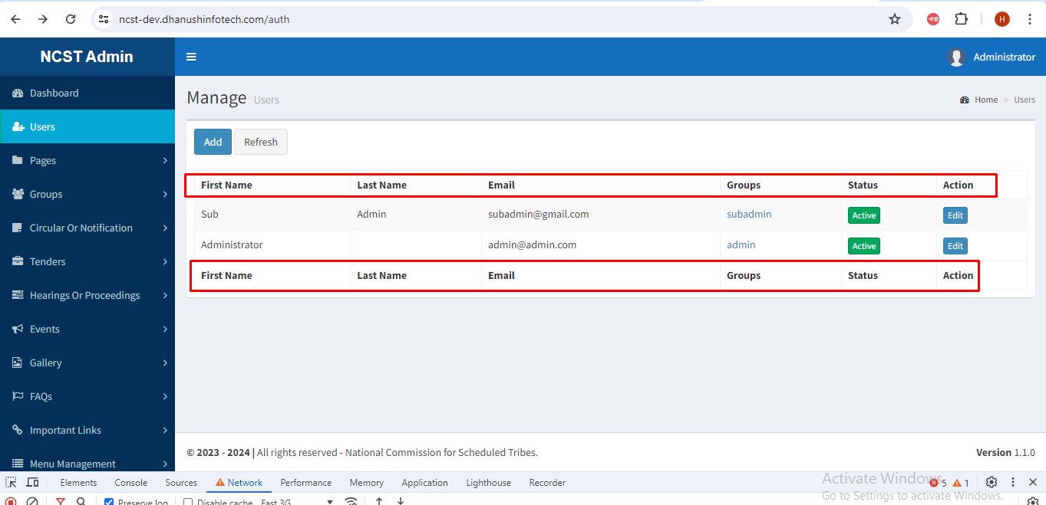

1. Web>>Admin>>Users>>Pagination is missing.

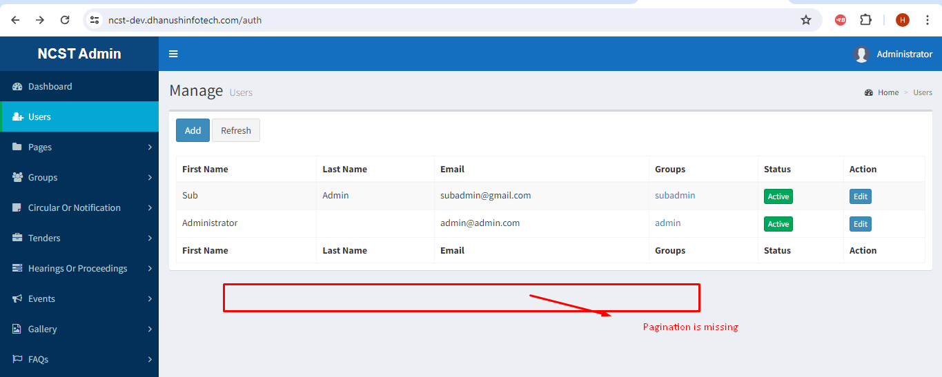

1. Web>>Admin>>Users>>Add>>First and Last Name is accept only alphabetical; It should not be accept the Numerical, Special character values.

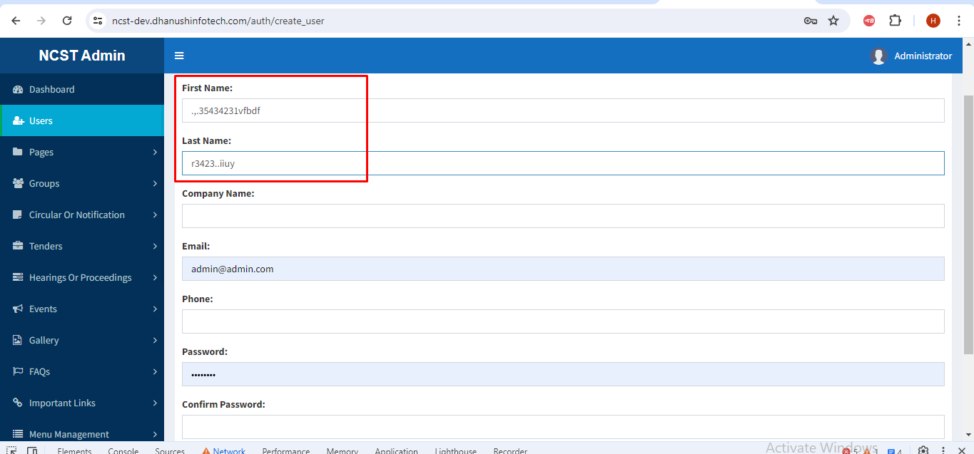

1. Web>>Admin>>Users>>Add>>Phone number text field should be starts with 6, 7, 8, 9, and accepts 10 digits of numerical value and It should not accepts Alphabetical, special Characters.

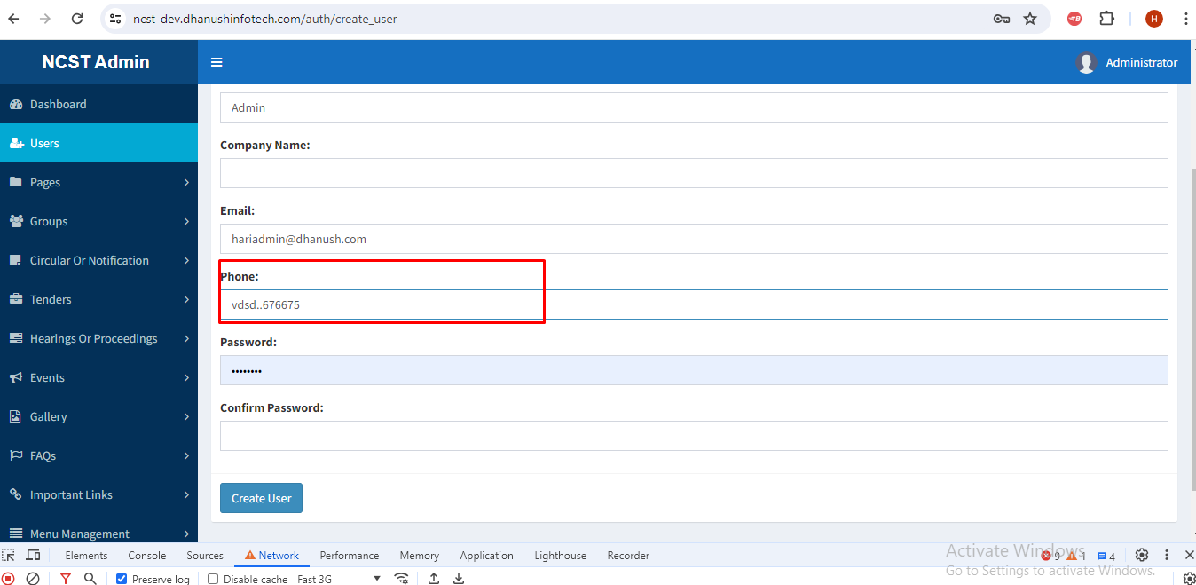

1. Web>>Admin>>Users>>When click on Refresh button, Users list page is not refreshing.

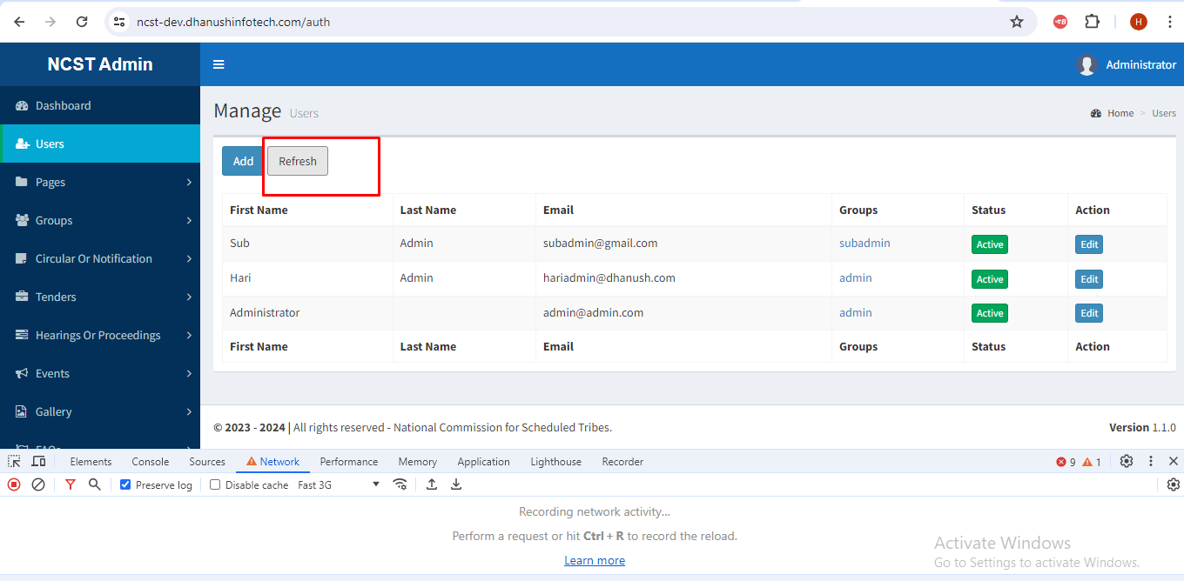

1. Web>>Admin>>Users>>Cancel button and Search field is missing.

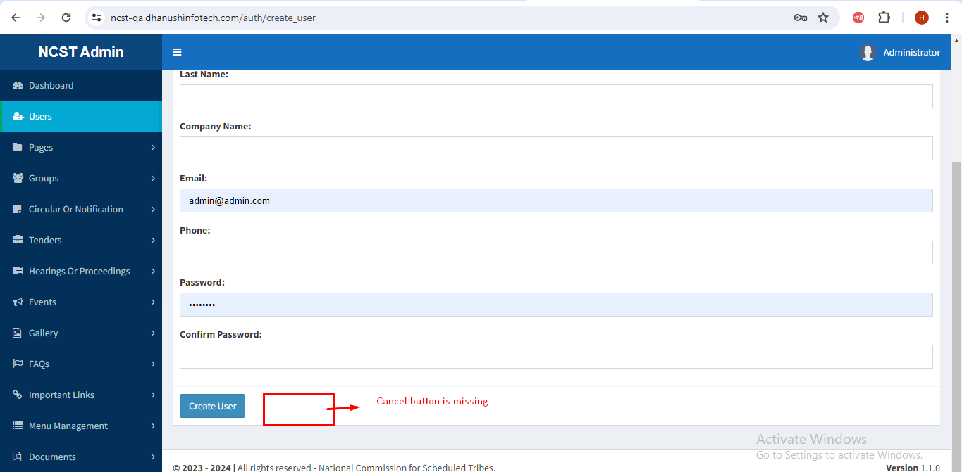

1. Web>>Admin>>Pages>>Manage pages>>When click on label View then after click on Edit or Delete getting Json response error message.

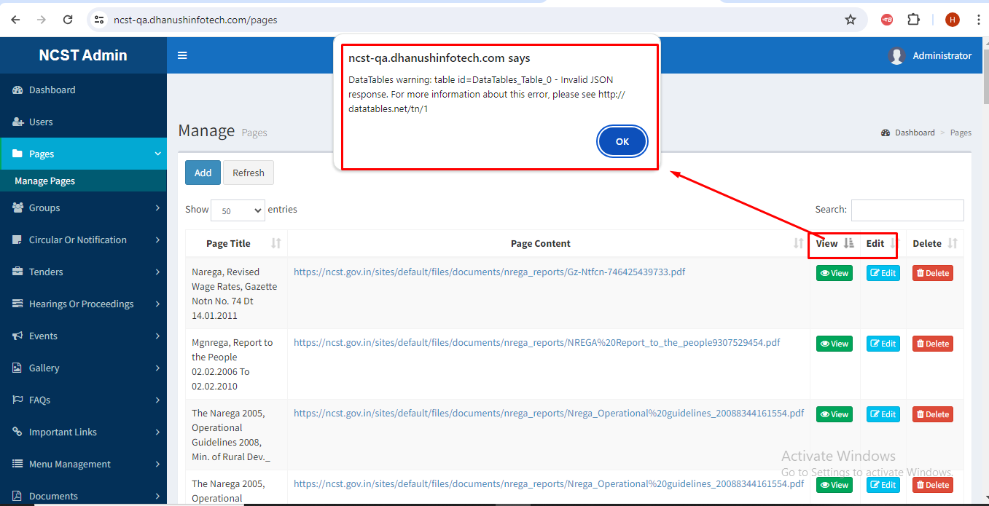

1. Web>>UI>>Present commission, Hearings and what’s new>>When click on Read more is not working.

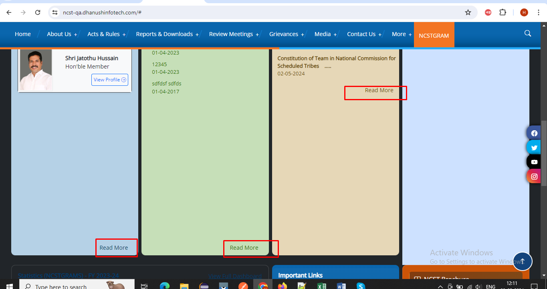

1. Web>>Admin>>Pages>>Manage pages>>Delete button>>Popup message is should be displaying Are you sure want to delete?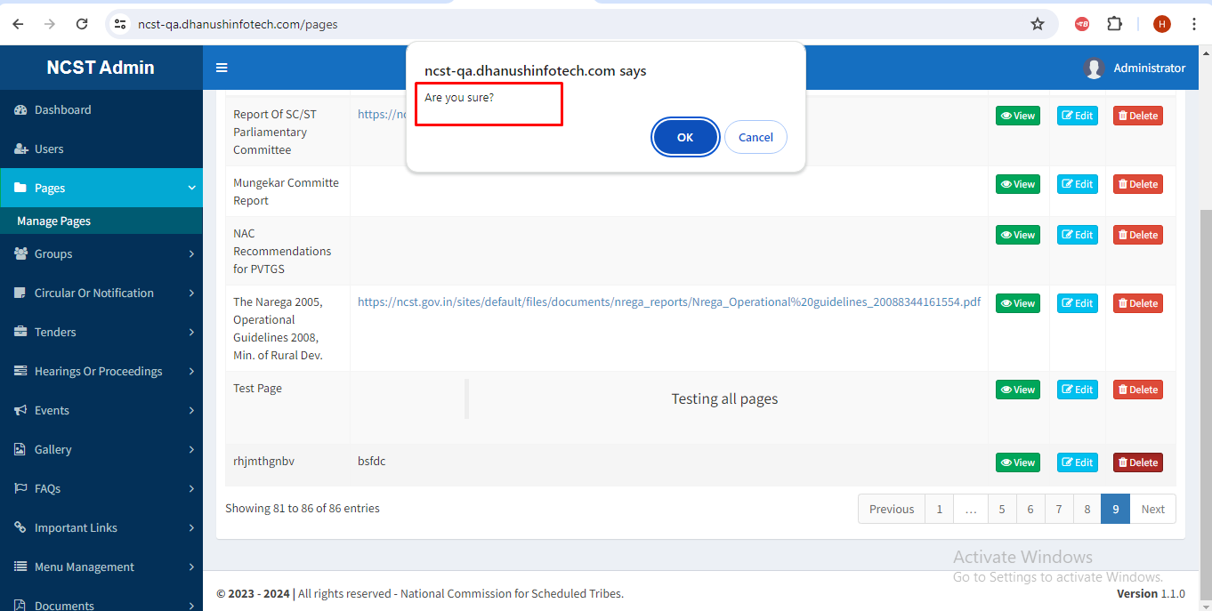
2. Web>>Admin>>Pages>>Manage pages>>successfully Delete the records, Again showing record in line listing.

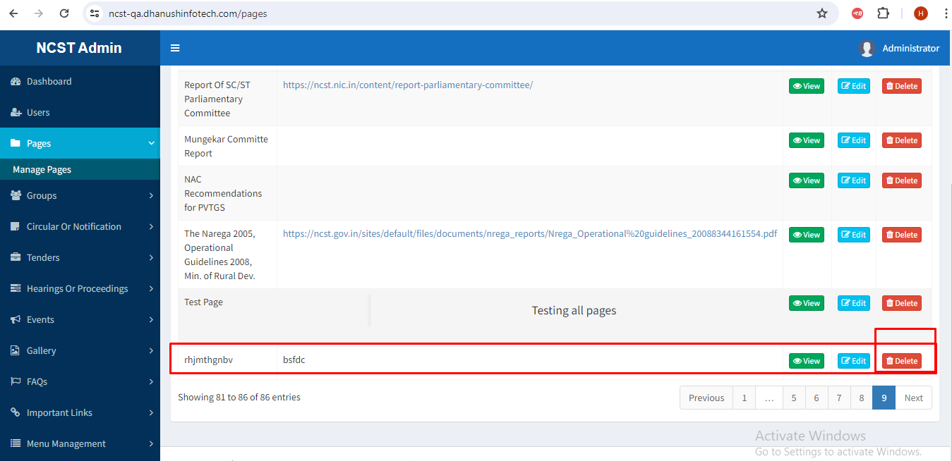

1. Web>>Admin>>Group>>Manage group>> When click on edit label getting Json response error message.

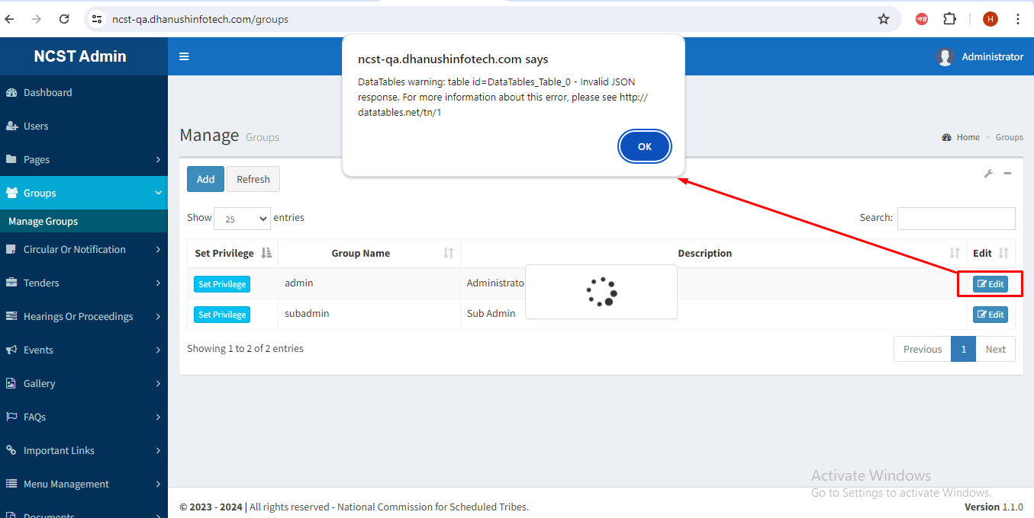

1. Web>>Admin>>Group>>Manage group>>Add>>Text field Label name is missing.

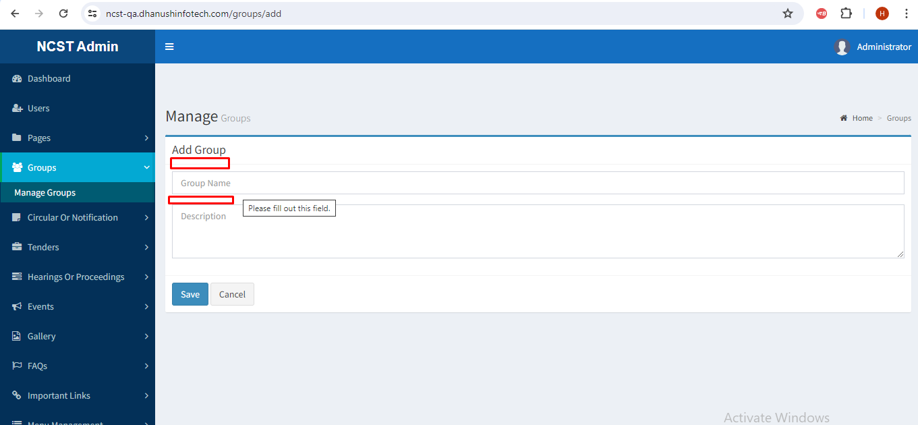

1. Web>> Admin>>Group>>Manage group>>Add>>Create the Record with Existing name, Duplicate records are inserting in line listing.

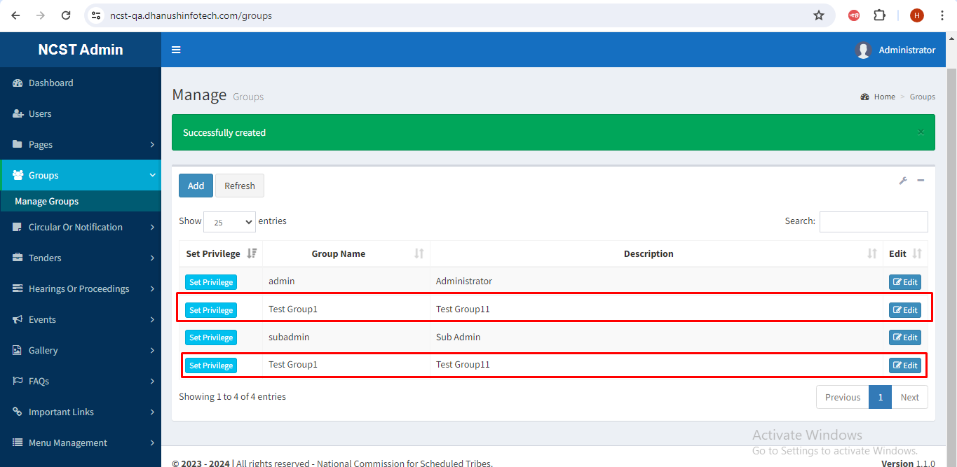

1. Web>>Admin>>Circular or Notification>>When click on Document, created on, Edit labels getting Json response error message.

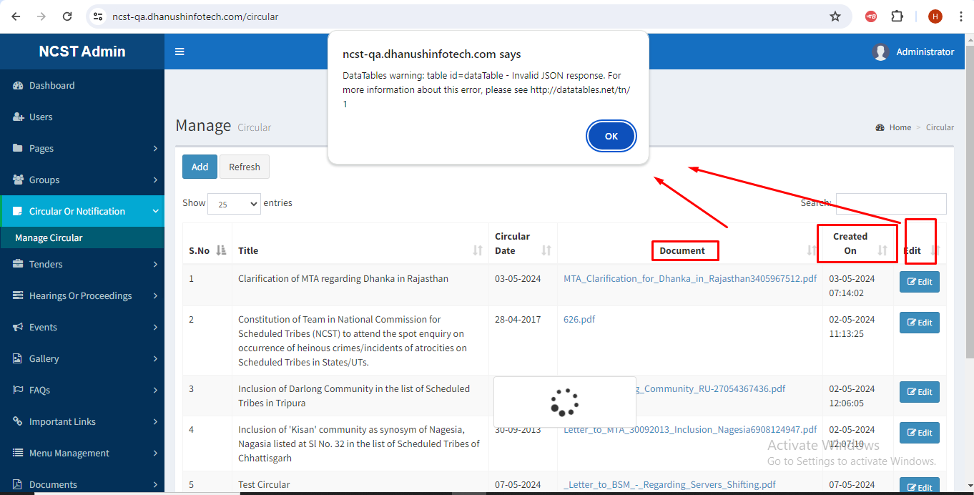

1. Web>>Admin>>Pages>>Manage pages>>Create the Record with existing name, getting Error occurred alert message.

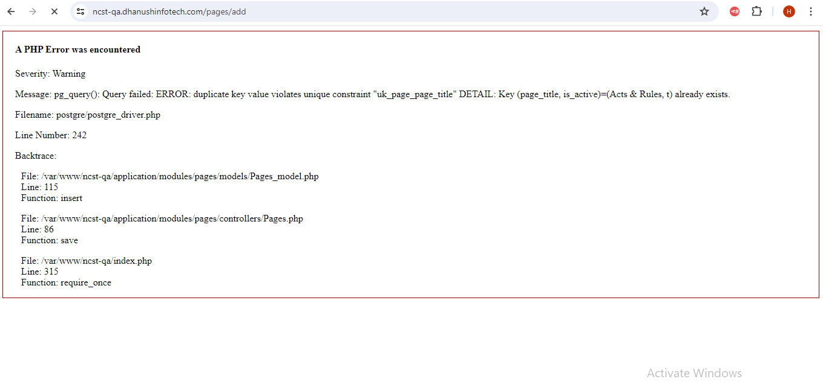

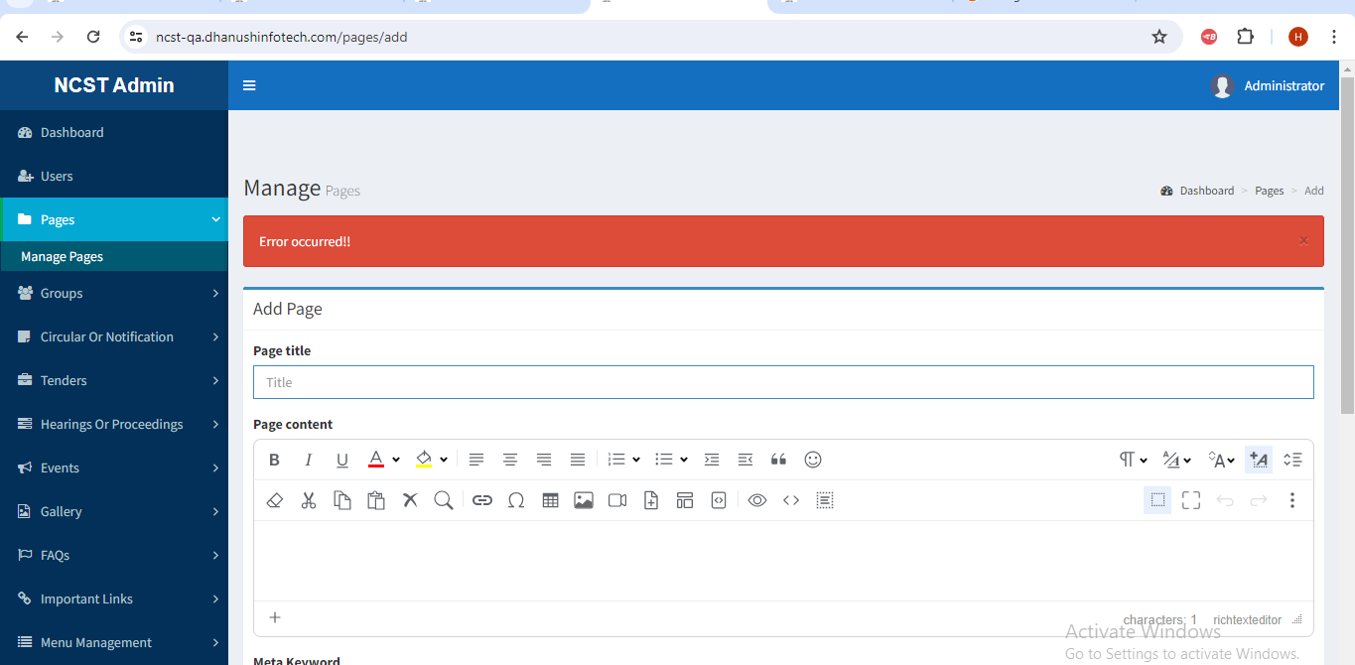

1. Web>>Admin>>Circular OR Notification>>Unable to add new circular, showing document Upload related issue (The upload destination folder does not appear to be writable).

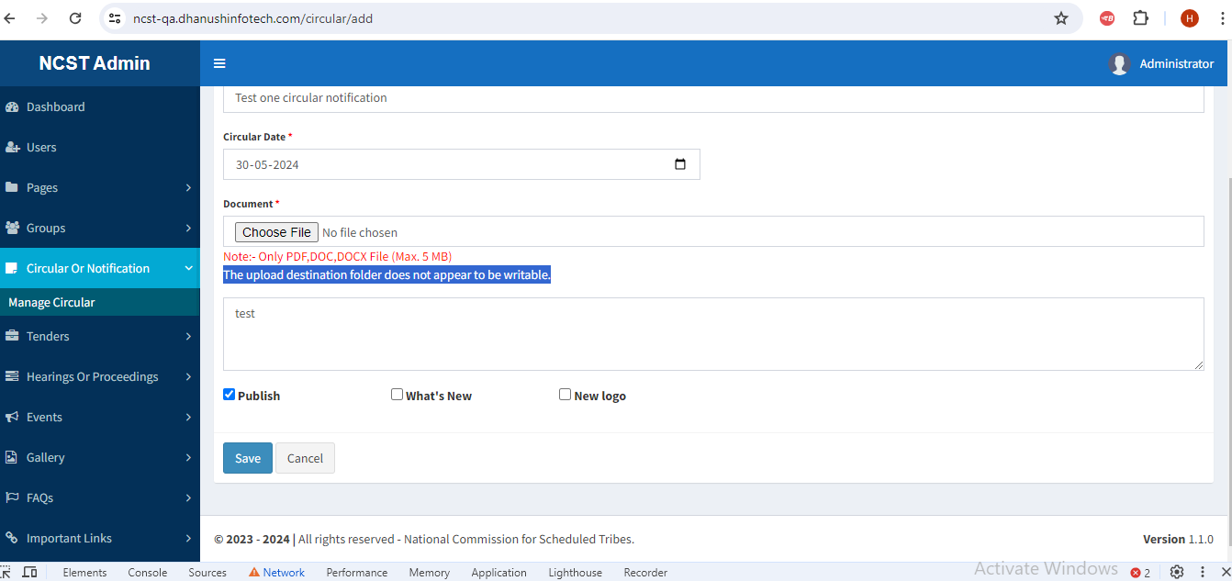

1. Web>>Admin>> Circular OR Notification>>Circular Date format Year is accepting more than digits. 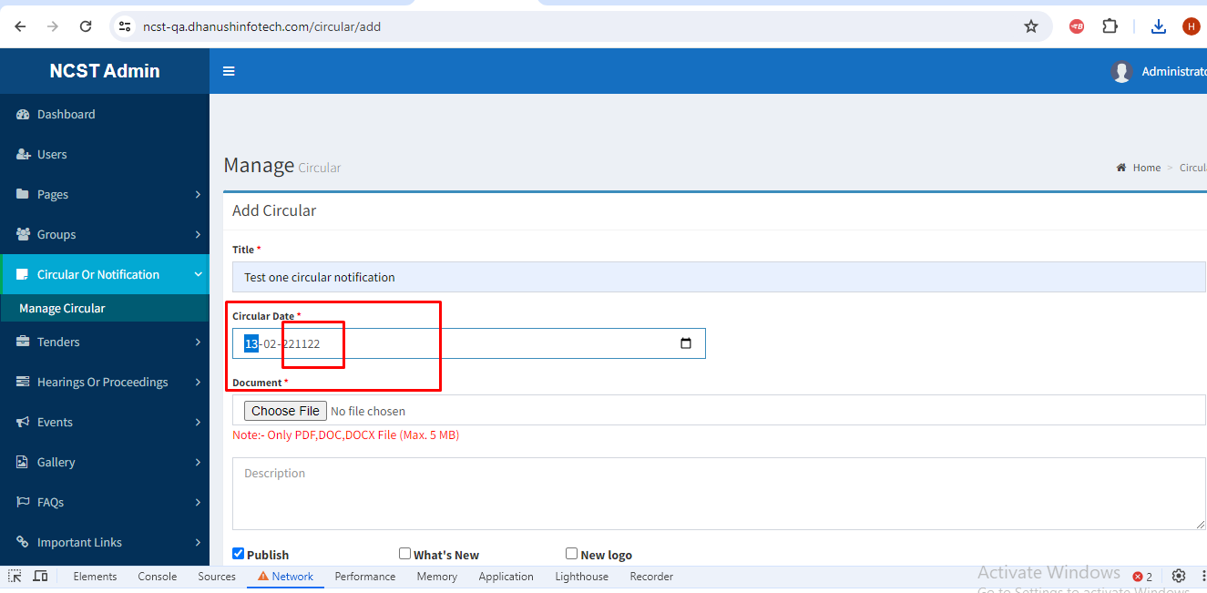
2. Web>>Admin>>Tenders>>Create the Record with Existing name, Duplicate records are inserting in line listing.

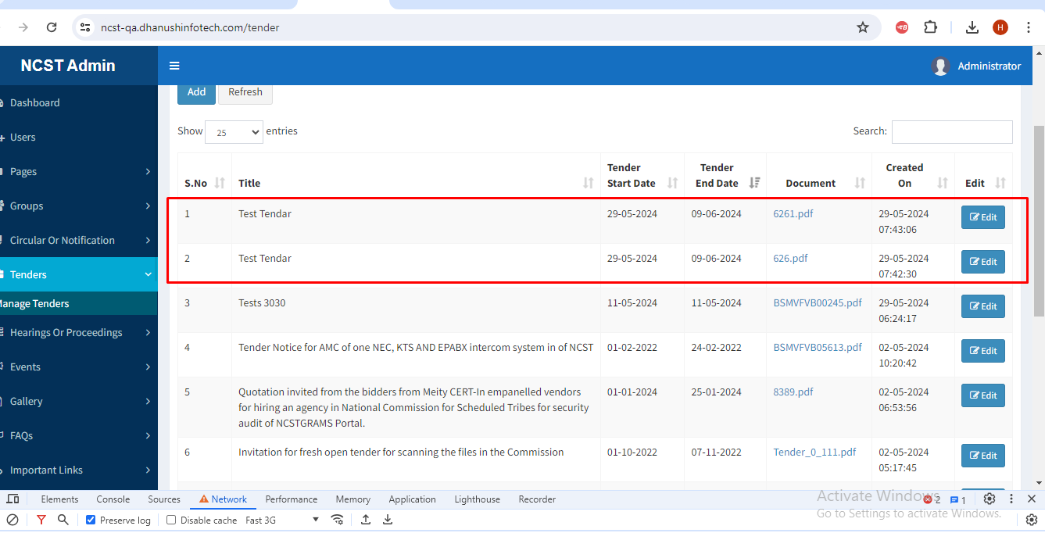

1. Web>>Admin>>Tenders>>Edits>>In Description text box, only first letter is displaying, it should be displaying entered all letters in text box.

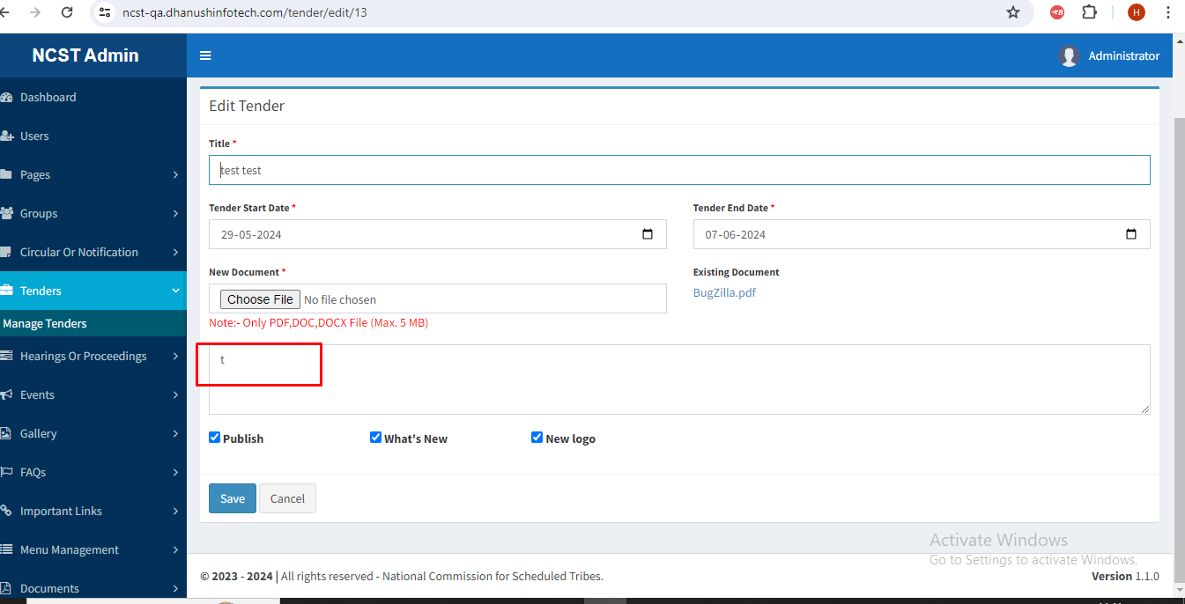

1. Web>>Admin>>Hearing of proceeding>>Add>>Edit>>Uploaded document is not populating, showing as No document Uploaded.

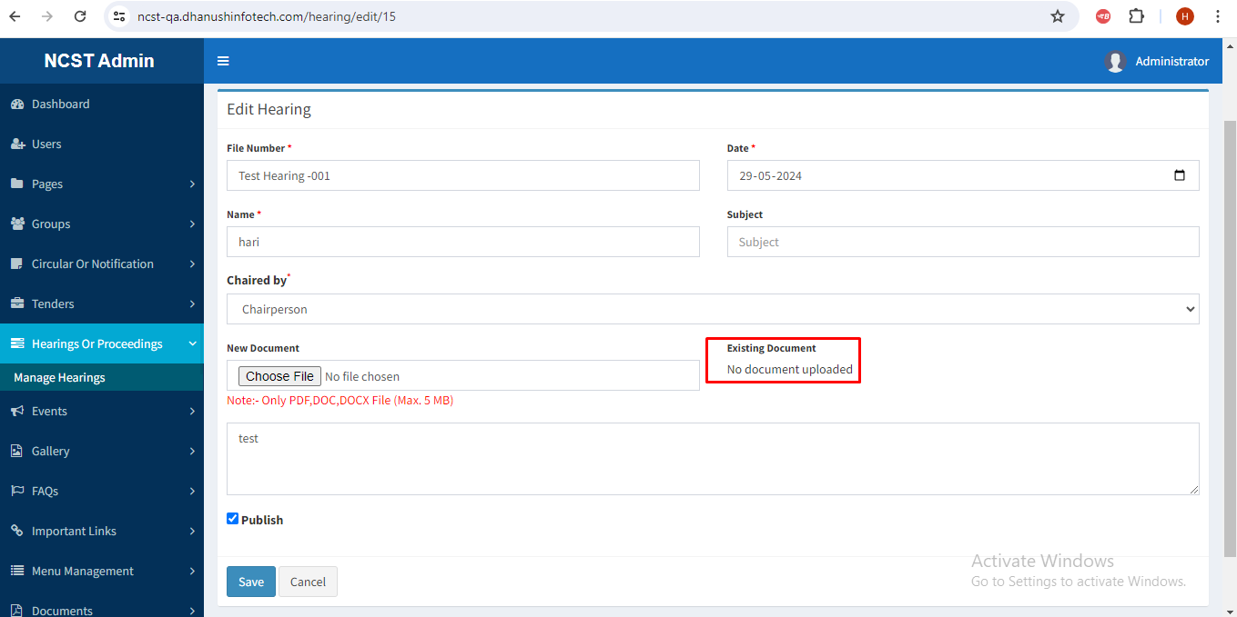

1. Web>>Admin>>Gallery>>Add>>Adding successfully, popup message is showing wrong as File type error.

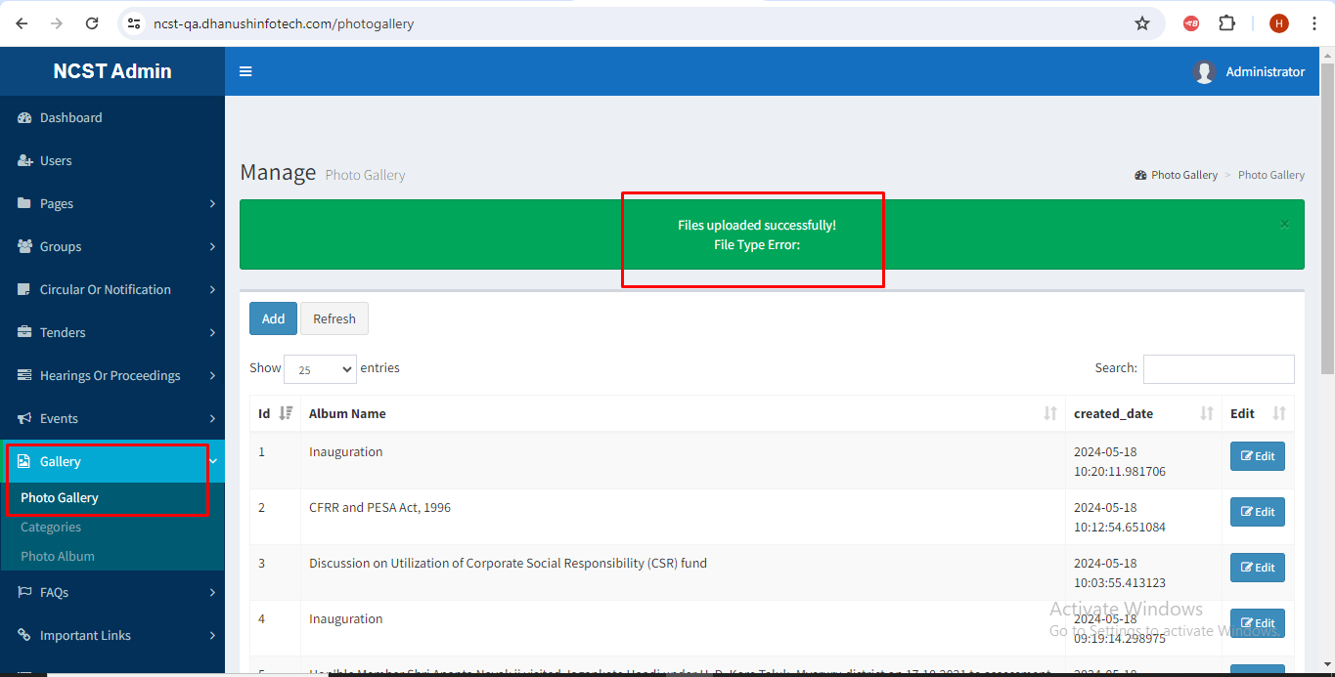

1. Web>> Admin>>Gallery>>in line listing created Date Sec format is showing wrong.

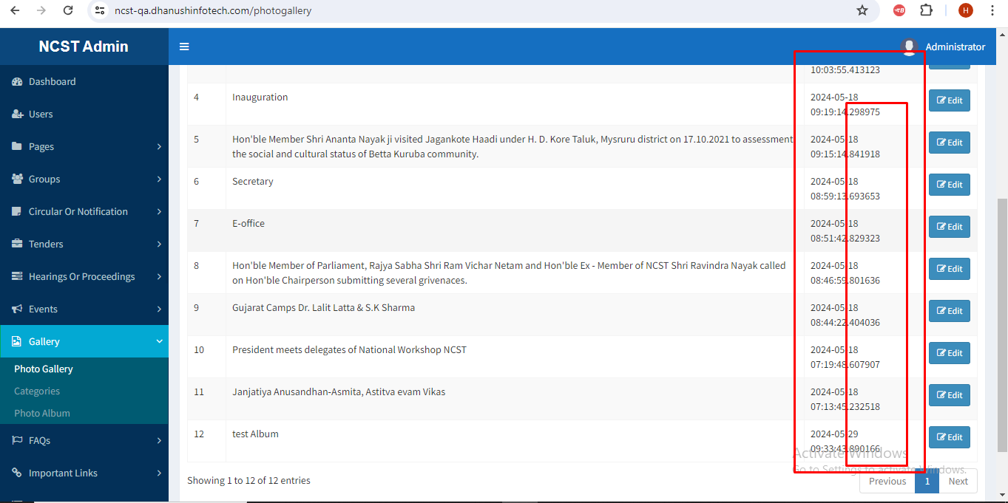

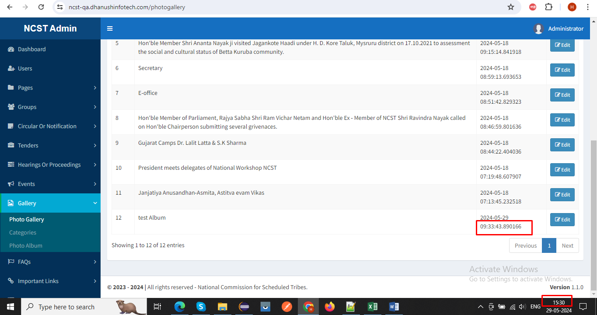

1. Web>> Admin>>Galley>>Photo gallery>>When click on album name, created date and Edit labels getting Json error.

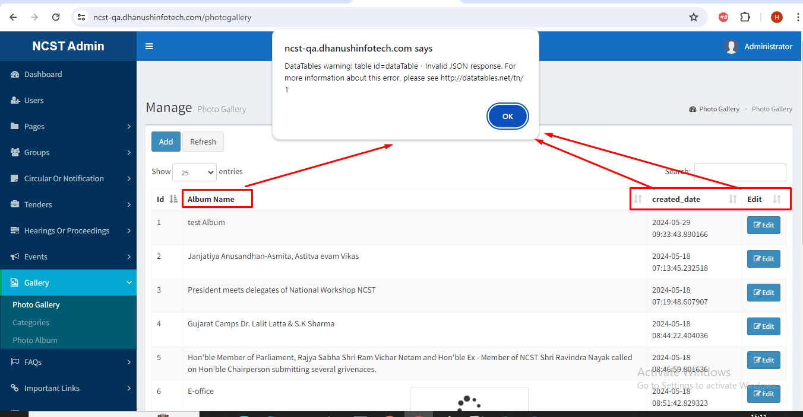

1. Web>> Admin>>Galley>>Photo gallery>>Edit>>Unable to Update and view Cover Photo and Album photo, getting page Not found.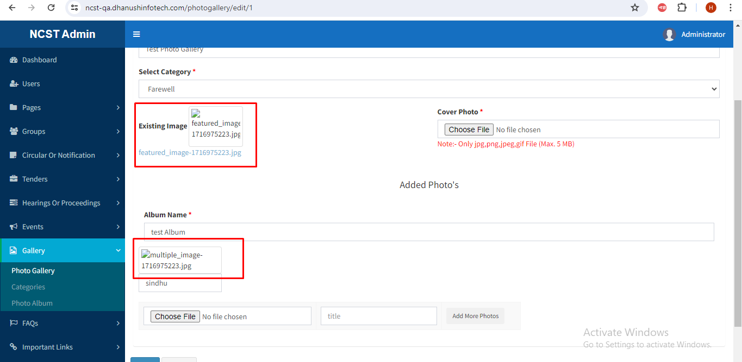

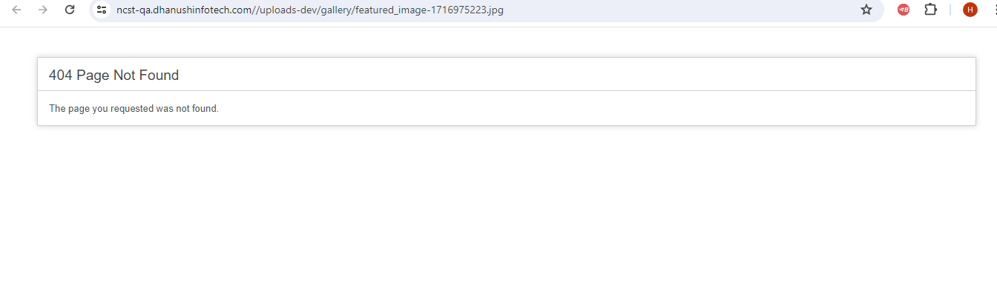

1. Web>> Admin>>Galley>>Category>>When click on save button, getting Query failed error.

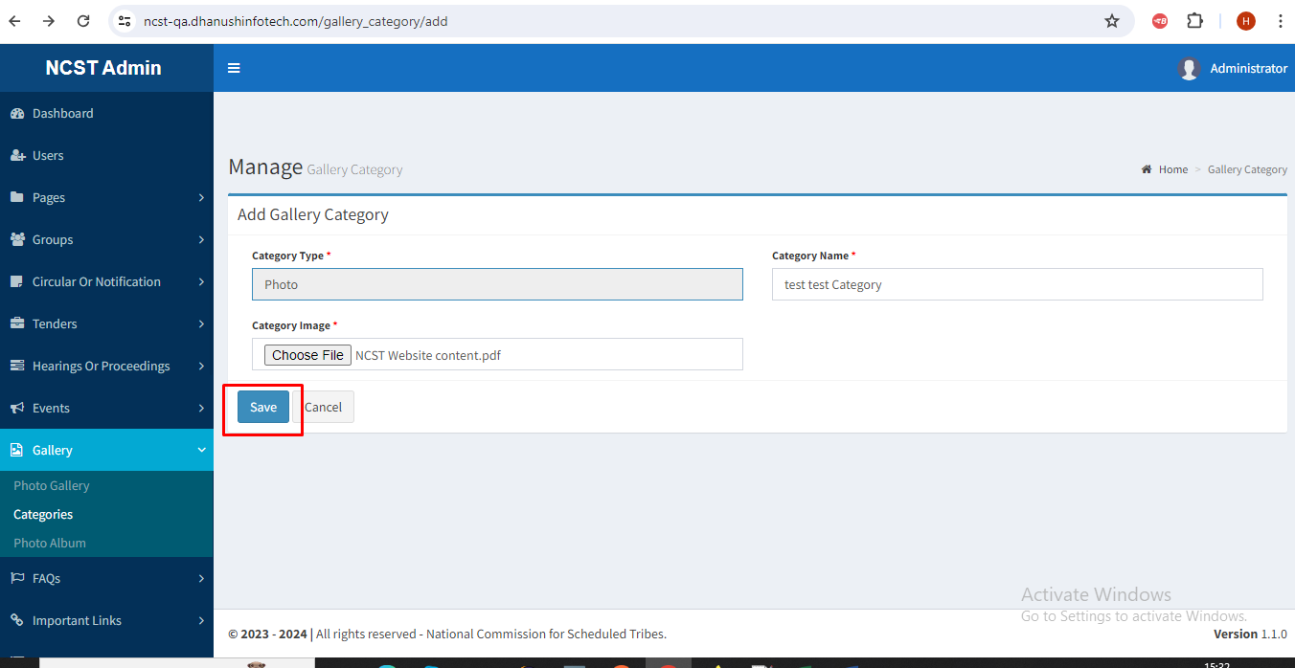

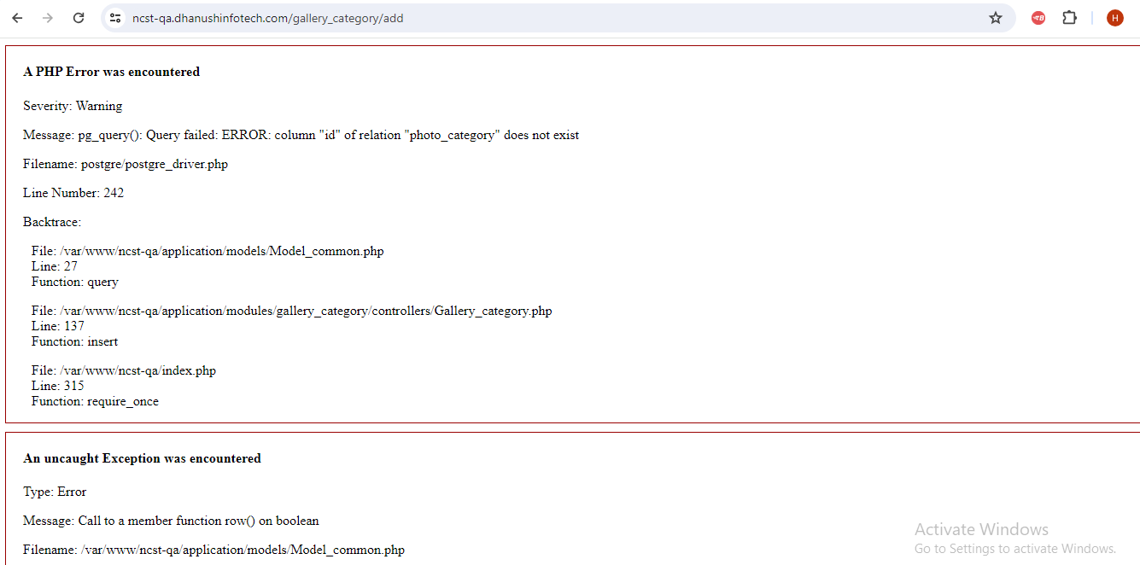

1. Web>>Admin>>Gallery>>Category>>Pagination is showing wrong.

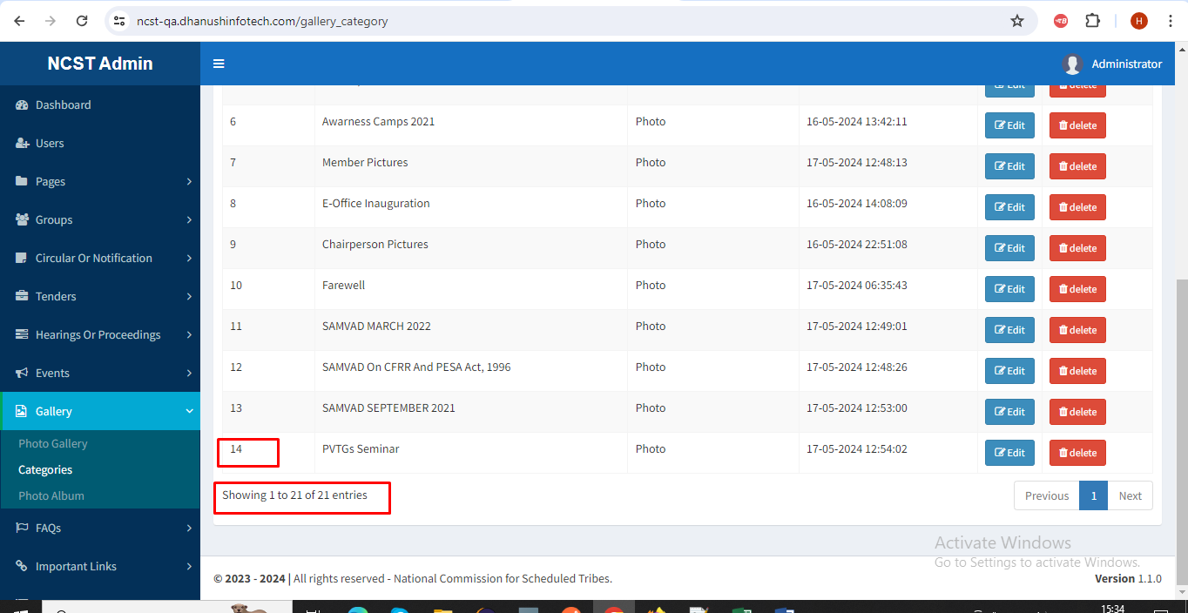

1. Web>>Admin>>Gallery>>When click on Photo album, getting page Not found.
2. Web>>Admin>>Important links>>Created date and System time is not matching.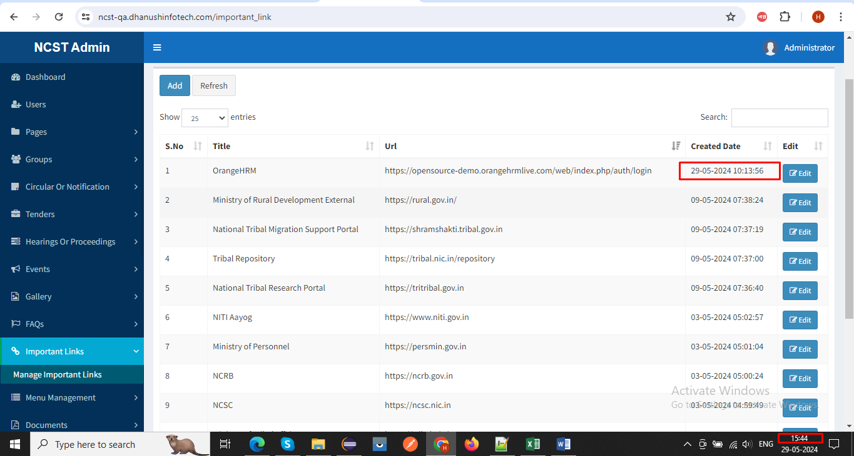
3. Web>>Admin>>Menu management>>menu list>>Add>> When click on Cancel button, screen is not closed again click on cancel button getting page not found.

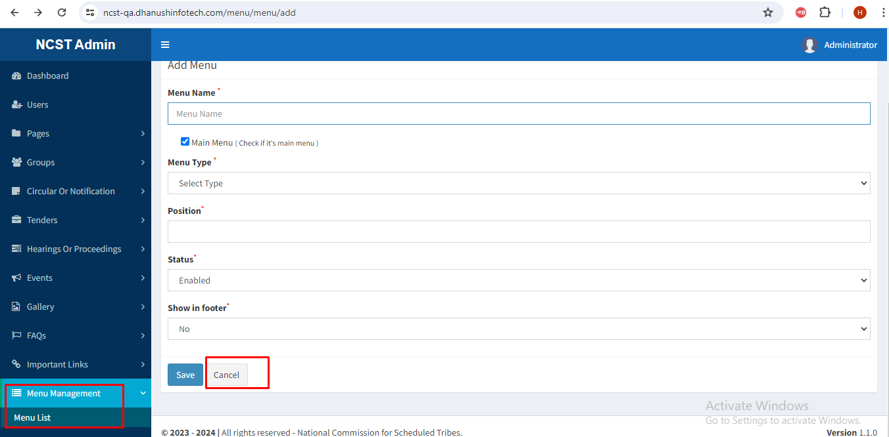

1. Web>>Admin>>Sliders>>Add>> Unable to Upload image getting the upload destination folder does not appear to be writable.

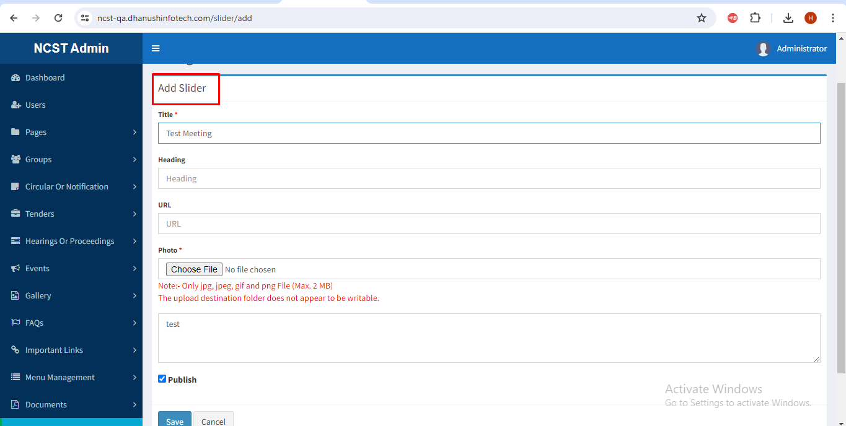

1. Web>>Admin>>Tour Report>>Edit>>When Update the Record, updated popup message is not showing.