Defect 1:

DSO>> Consignment transfer request>> in remarks column given remarks is not displaying please refer screenshot. –

* API

While doing retesting on this this issues in remarks column the text should be wrapped please refer screenshot.

* Done

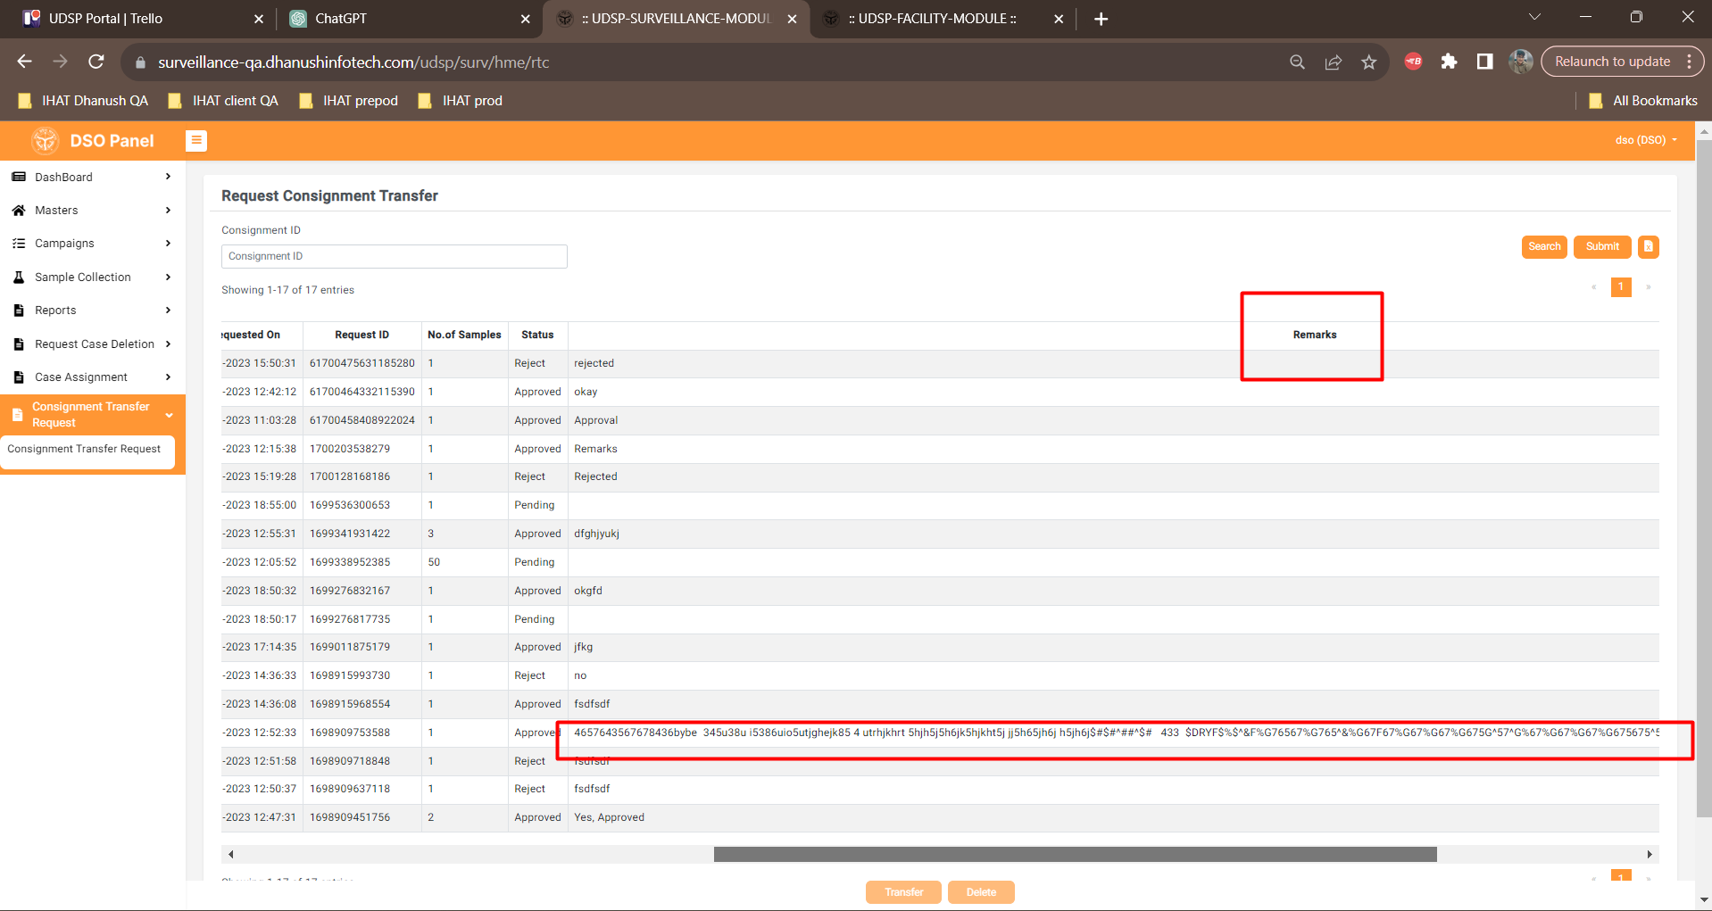

Defect 2:

SSO>>> Consignment transfer request >> In search filters consigner and lab name and requested by fields are blinking while clicking on submit button please refer screenshot. (UI)

Same issue is replicating in DSO. Please refer screenshot,

* **Well it’s not a blinking kind where it is a re-fetching of Consignors & Labs from API end**

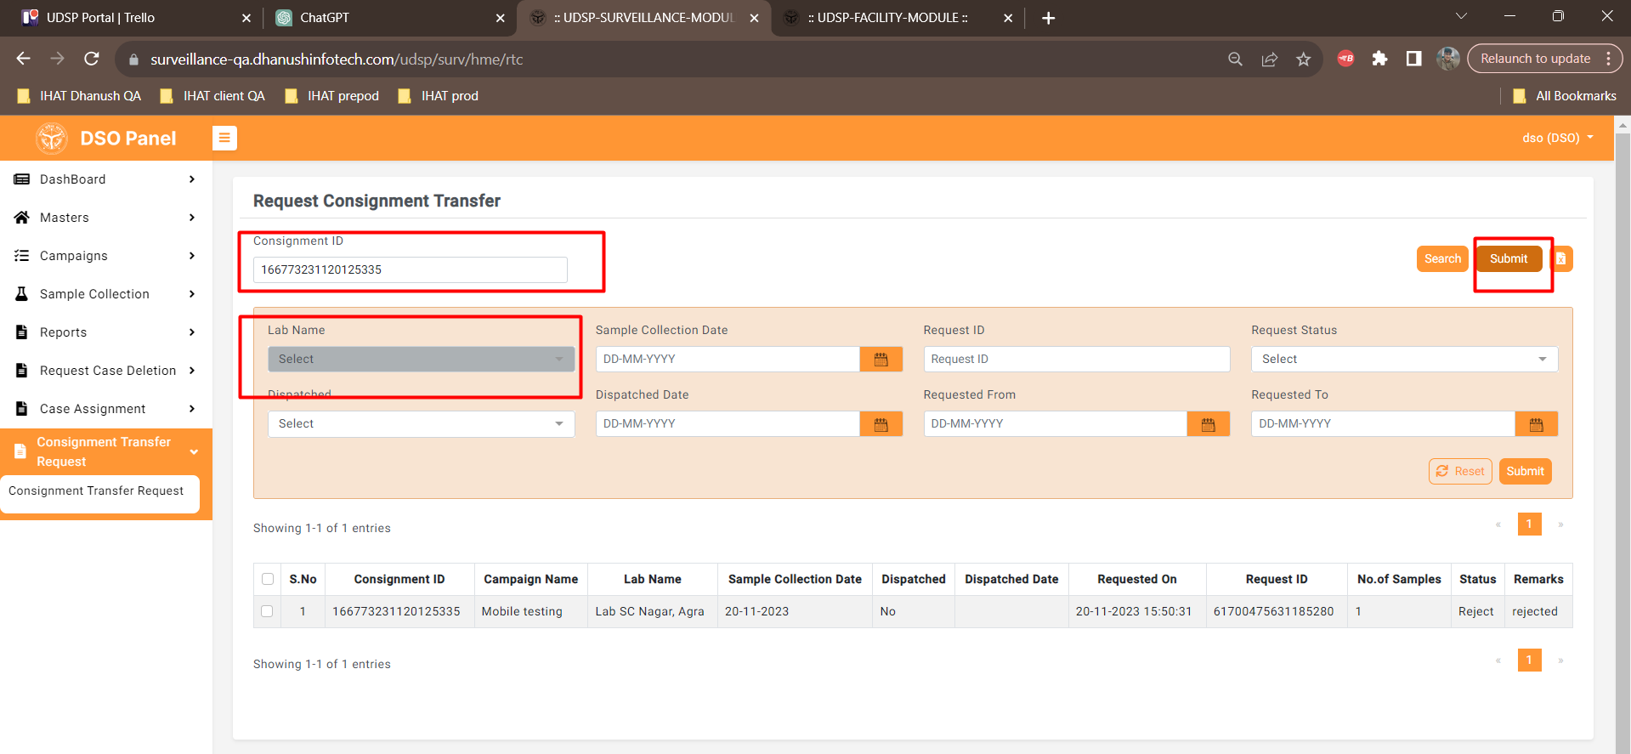

Defect 3:

Facility>> Consignment transfer request>> In remarks column the text is not wrapped please refer screenshot.

While doing retesting on this this issues in remarks column the text should be wrapped please refer screenshot.

* **Done**

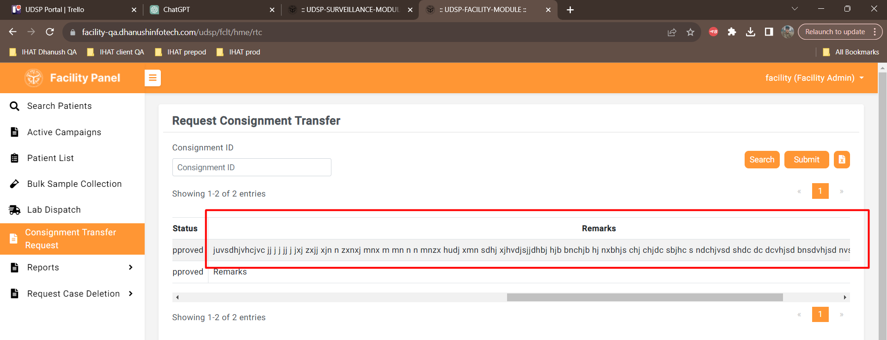

Defect 4:

/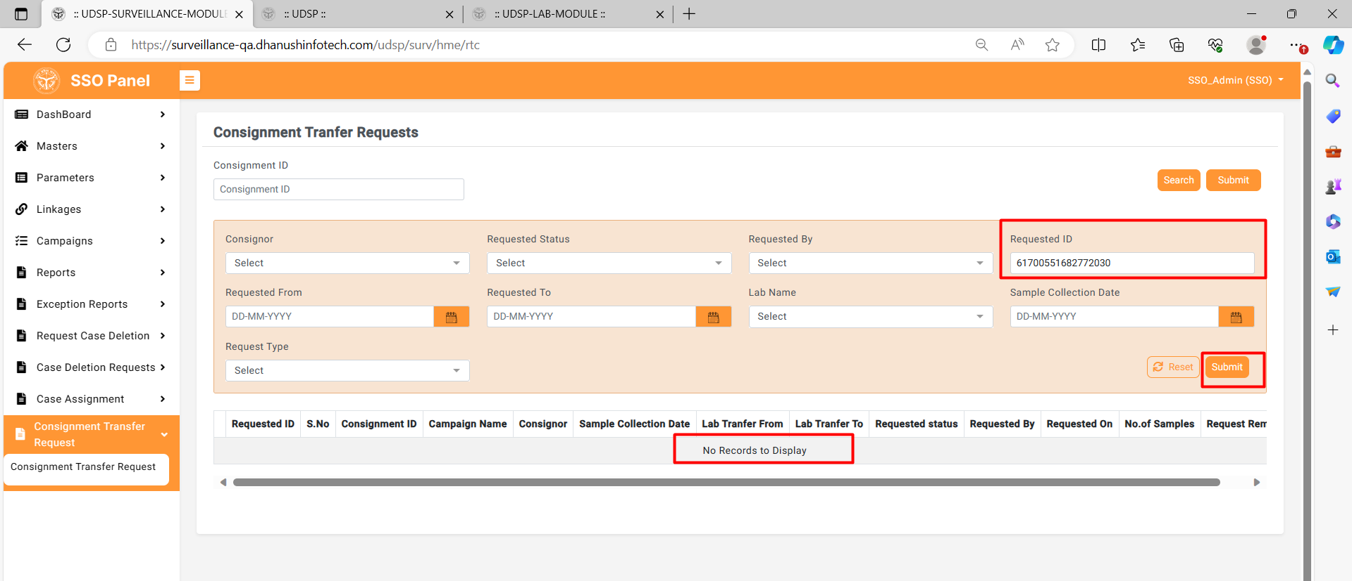

Defect 4:

Here with this requested id 961700551682772030 if we search no records to display alert is displaying please referscreenshot.

* **API**

