Defect 86:

Temple management>> Counter login>> Seva booking>> Selecting today data and here select time field time is displaying as morning slots (6.00 Am to 7.00 Am) here morning time slots should not displayed. Now time is 4.oo pm.

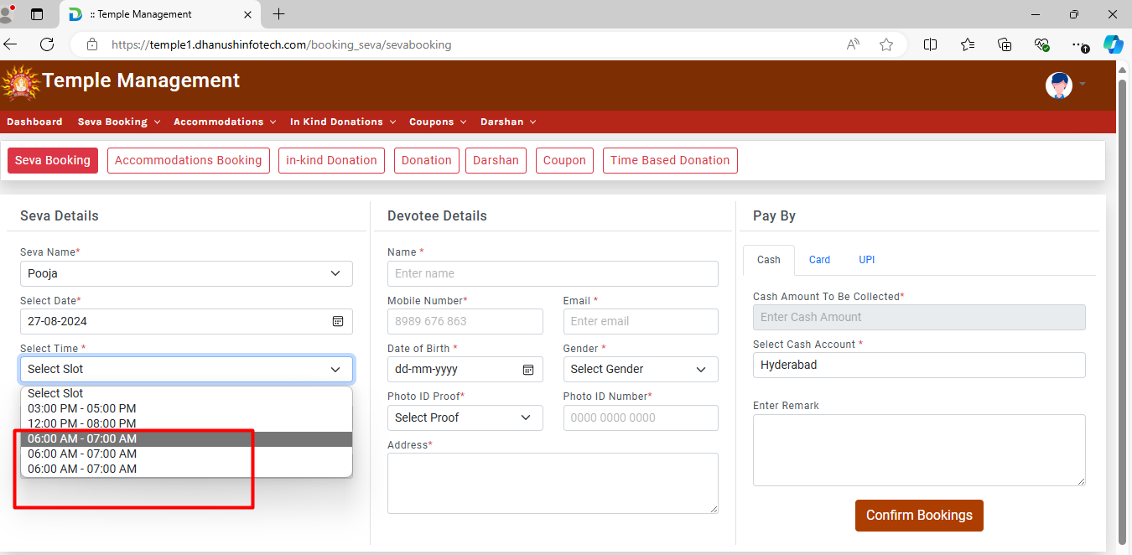

Defect 87:

Temple management>> admin>> Total coupon booking>> Clicking on total ticket booking module here this alert is displaying like data table error please refer screenshot.

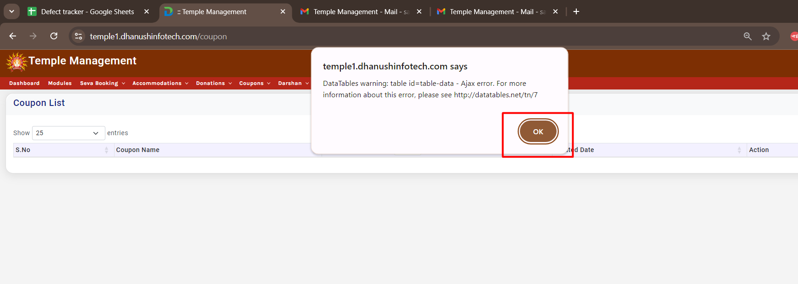

Defect 88:

Temple management>> Counter login>> Seva booking>> Mail>> In mail logo is not displaying properly with name please refer screenshot.

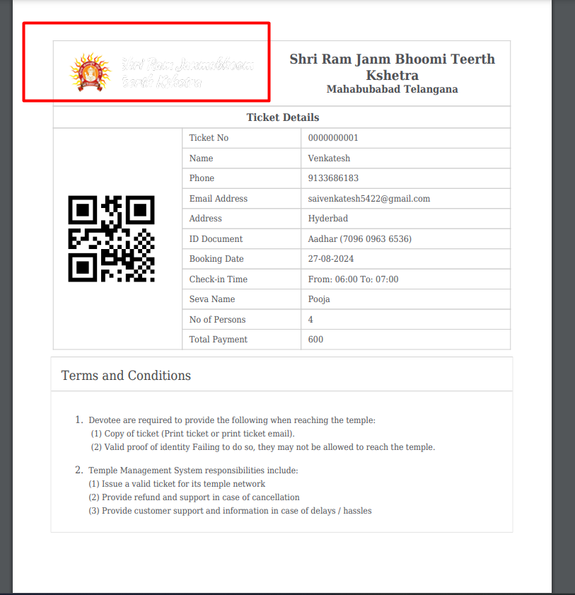

Defect 89:

Temple management>> Admin>> Creating same seva with same time and same date here it is accepting and while booking the seva, seva time is displaying three times please refer screenshot.

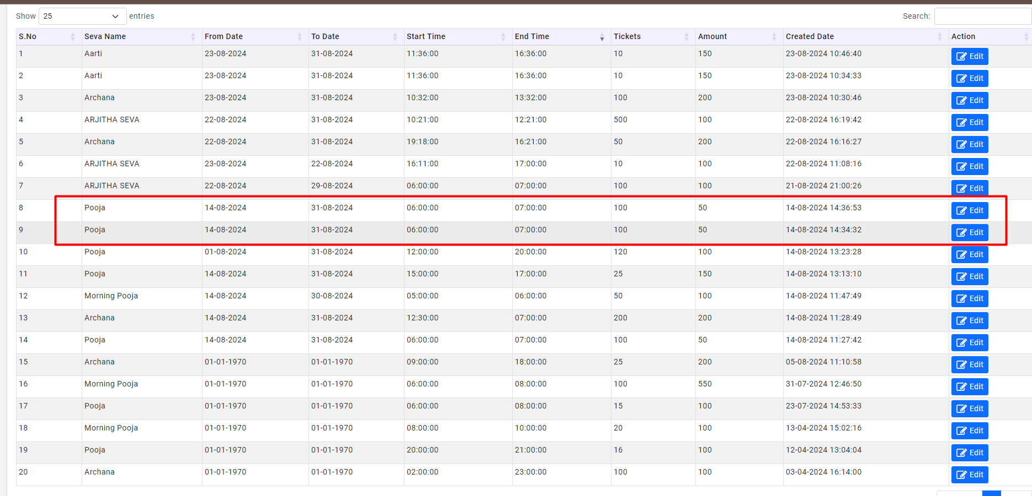

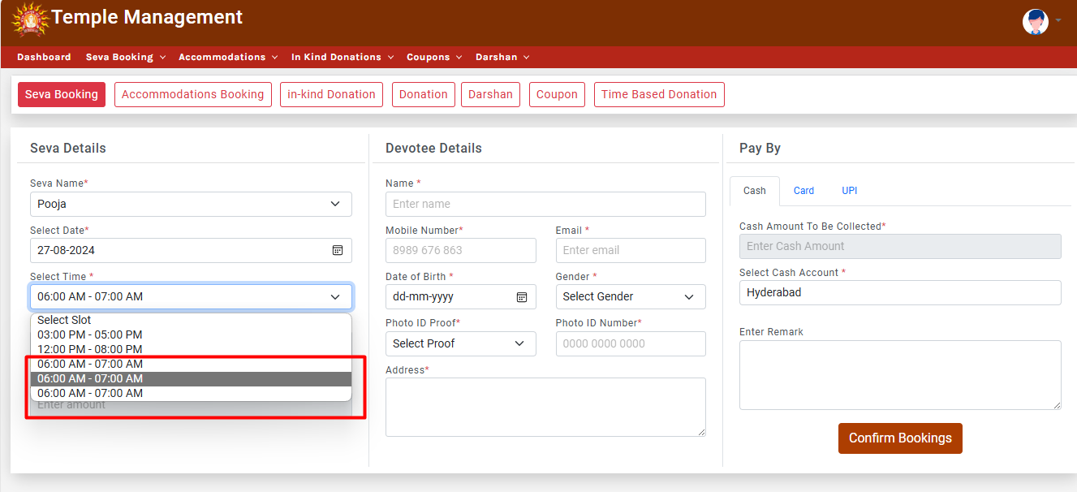

Defect 90:

Temple management>> Counter login>> Accommodation booking>> Here in the admin access accommodation name is not published but here in the booking status the details are displaying please refer screenshot.

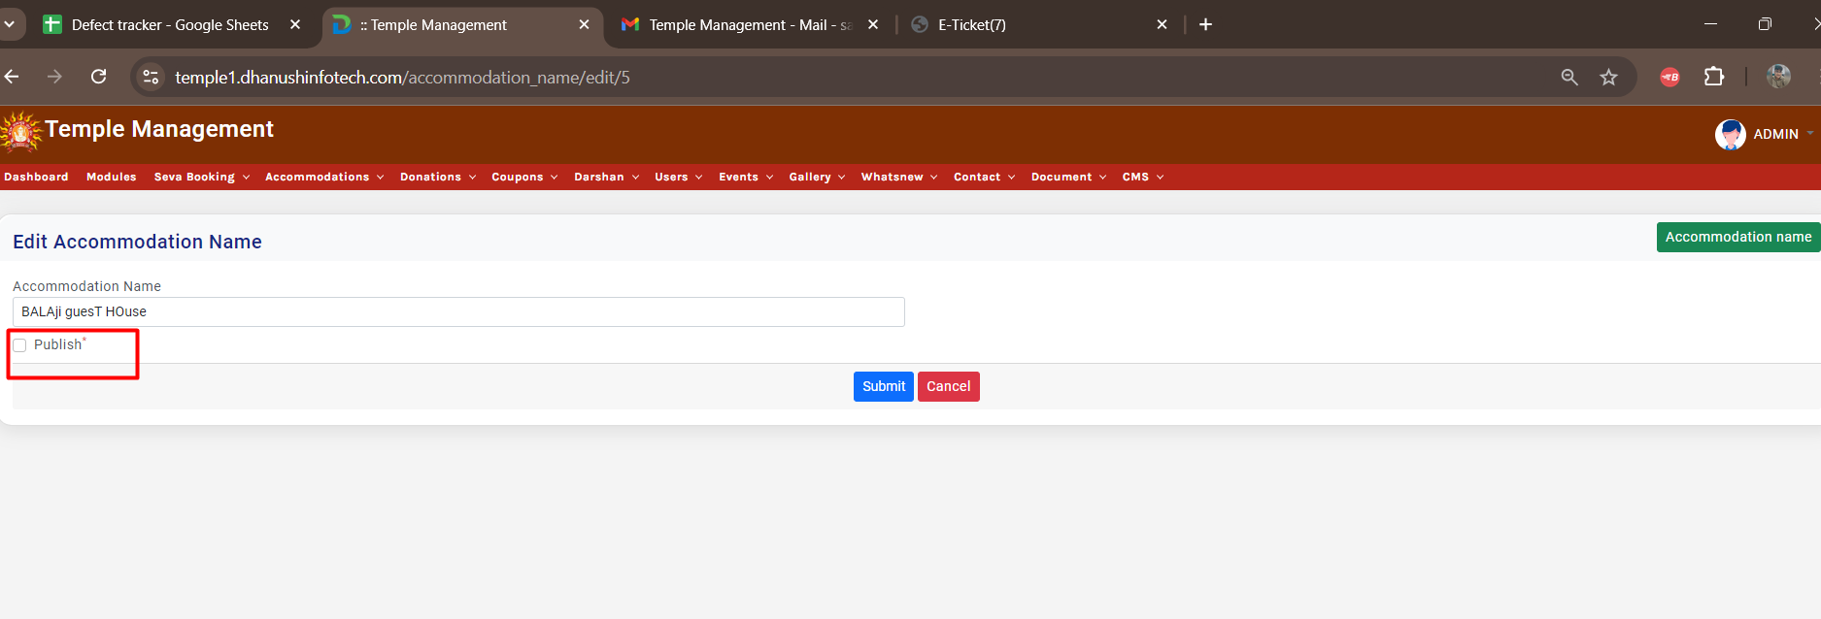

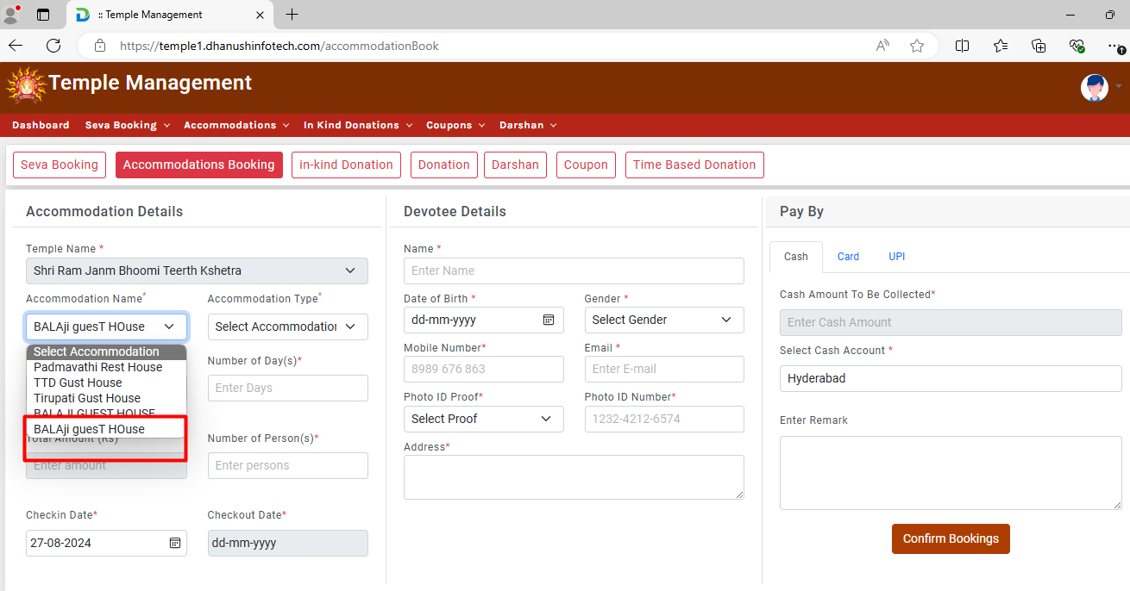

Defect 91:

Temple management>> Counter login>> Accommodation booking>> Clicking on confirm booking here no alert is displaying with giving wrong details Please refer screenshot

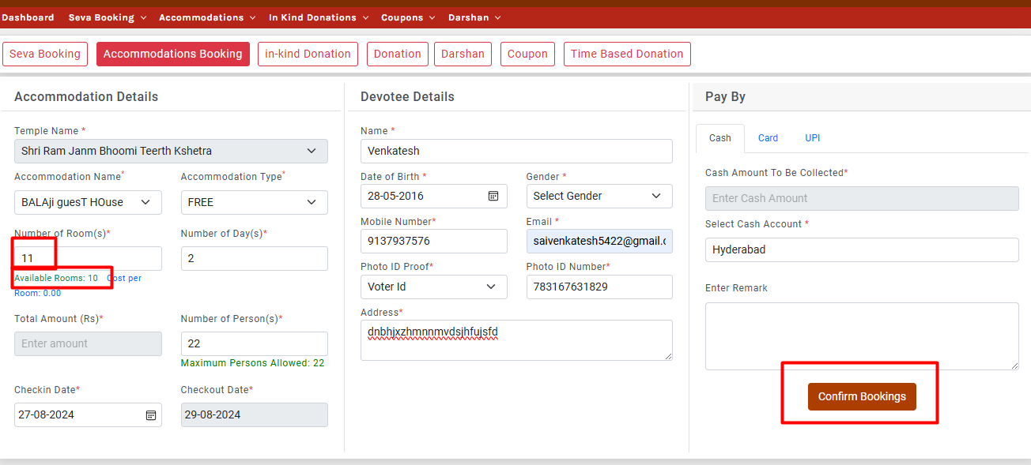

Defect 92:  
Temple management>> Counter login>> Accommodation booking>> Confirm booking functionality is not working.

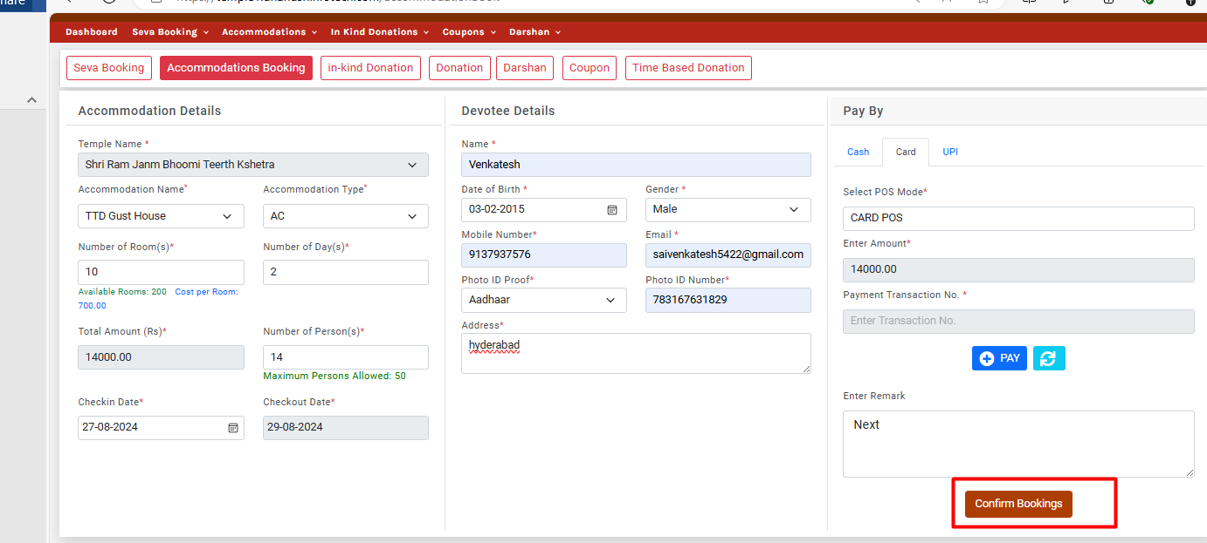

Defect 93:

Temple management>> Counter login>> In-kind donation>> Adding all details and clicking on confirm button here it is displaying error occurred.

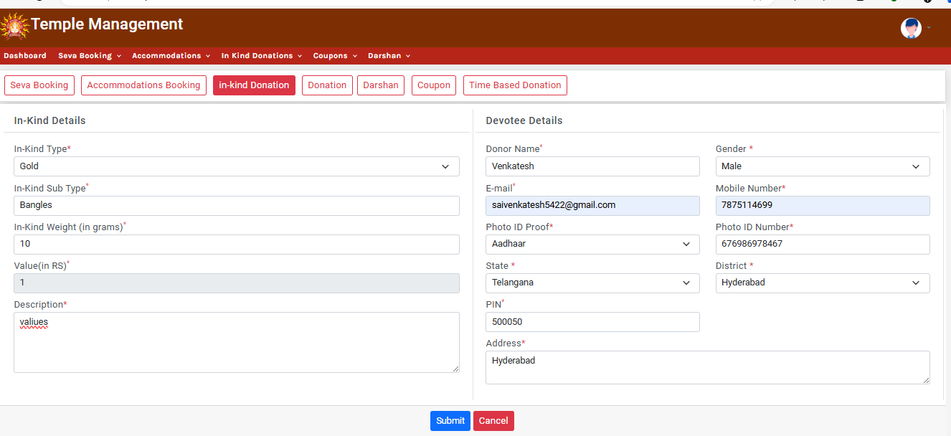

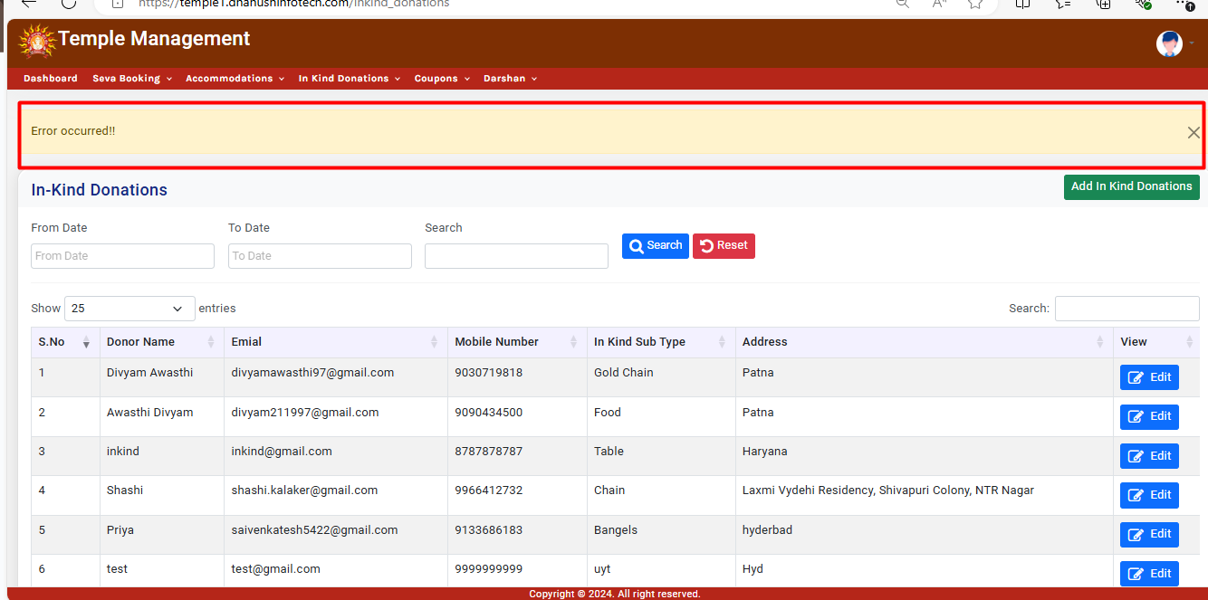

Defect 94:

Temple management>> Counter login>> Darshan>> Here in the select date past Dates are displaying please refer screenshot.

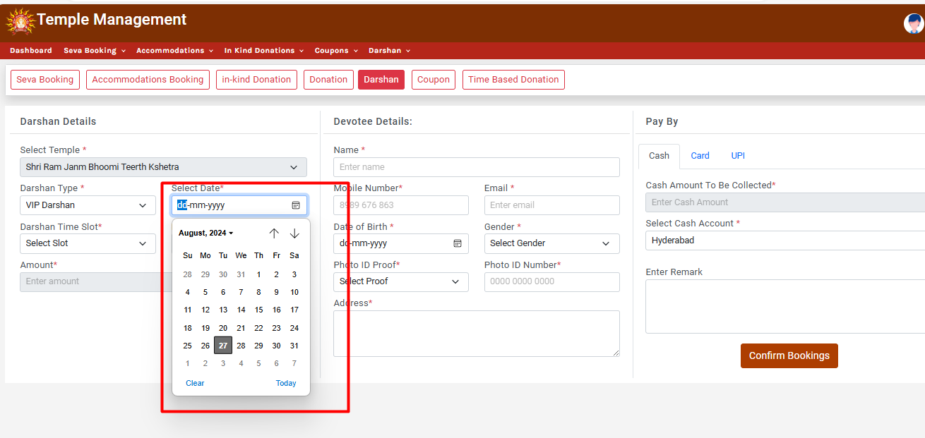

Defect 95:

Temple management>> Counter login>> Darshan> Selecting same data and again dates past time like 3.00 am to 4.00 am time is displaying please refer screenshot.

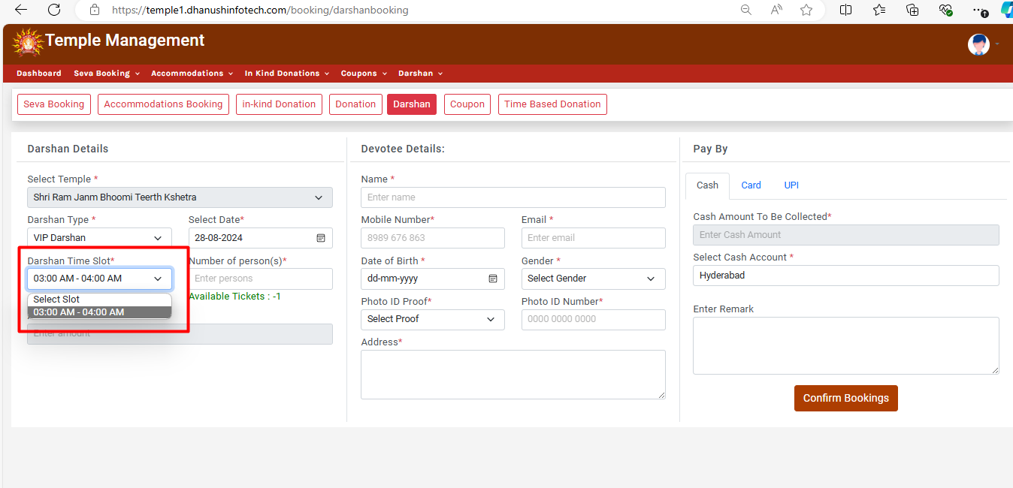

Defect 96:

Temple management>> Counter login>> Darshan>> Here selecting the darshan time slot here available ticket count is displaying as -1 please refer screenshot.

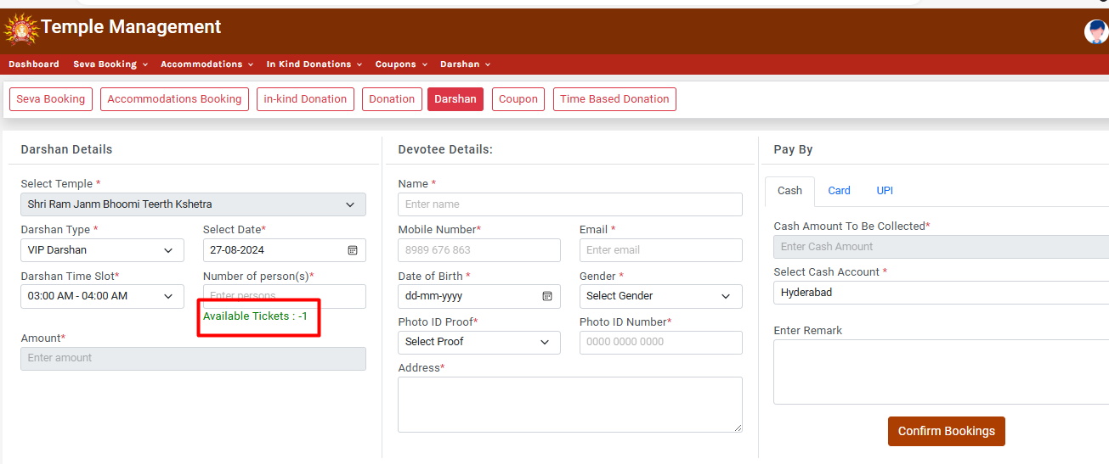

Defect 97:

Temple management>> Counter login>> Darshan>> After adding wrong details also if I click on confirm booking here it is displaying booking confirmed, please refer sxreenshot.

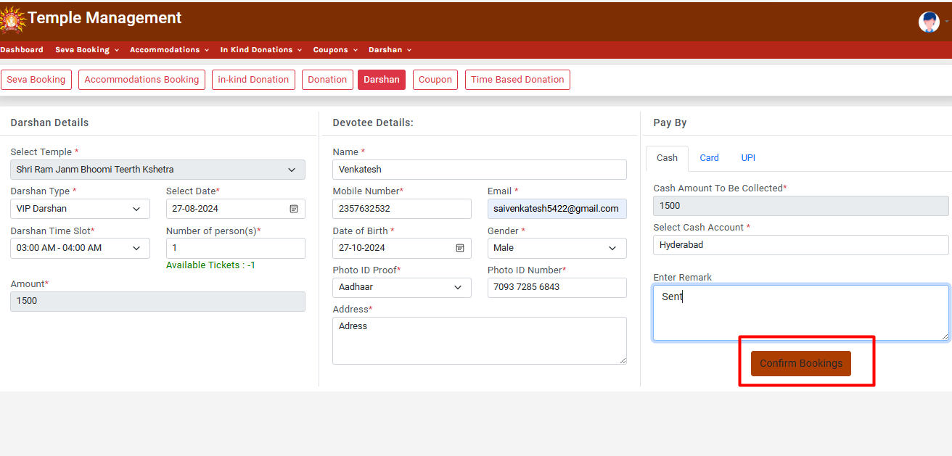

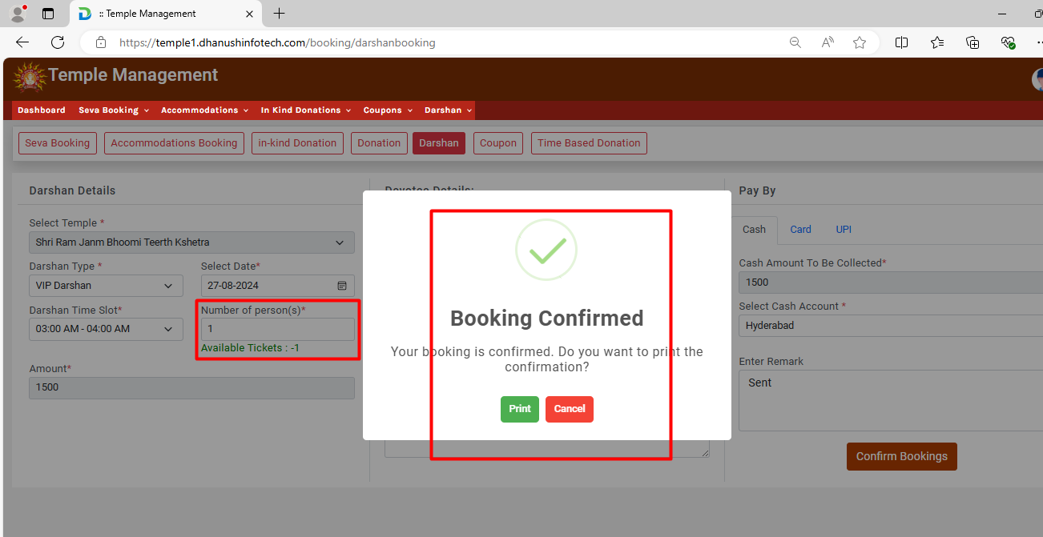

Defect 98:

Temple management>> Counter login>> Accommodation booking>> Here in the select room category Duplicate dropdowns are displaying please refer screenshot.

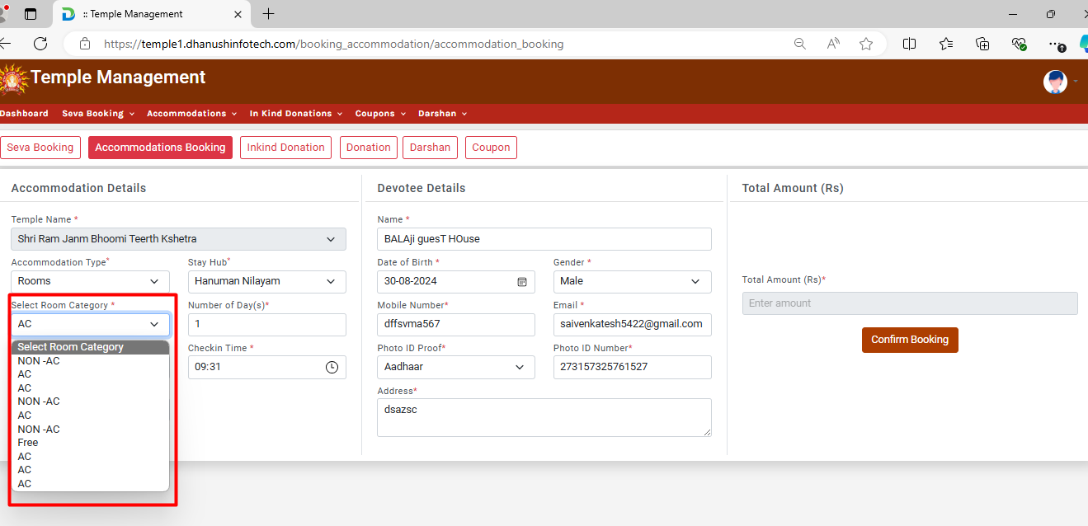

Defect 99:

Temple management>> admin>. Add user>. Here in the phone field alphabets are accepting please refer screenshot.

