Example->1

➔ Slide#3 is raised in Labs Master screen, but now the same has been asking for Private Lab Registration

➔ please share the validation rules for below screen

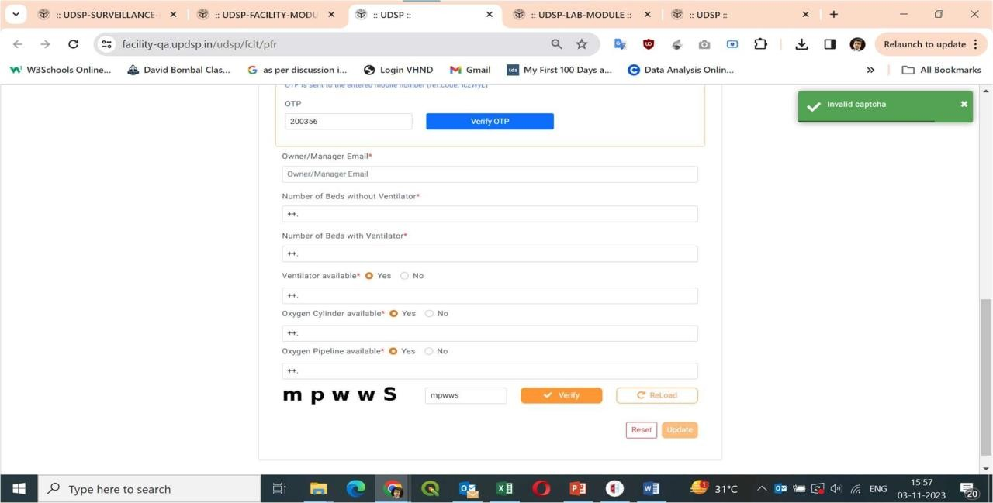

Example-> 2

➔ It’s a free text box, where user can enter any, while searching in dropdowns

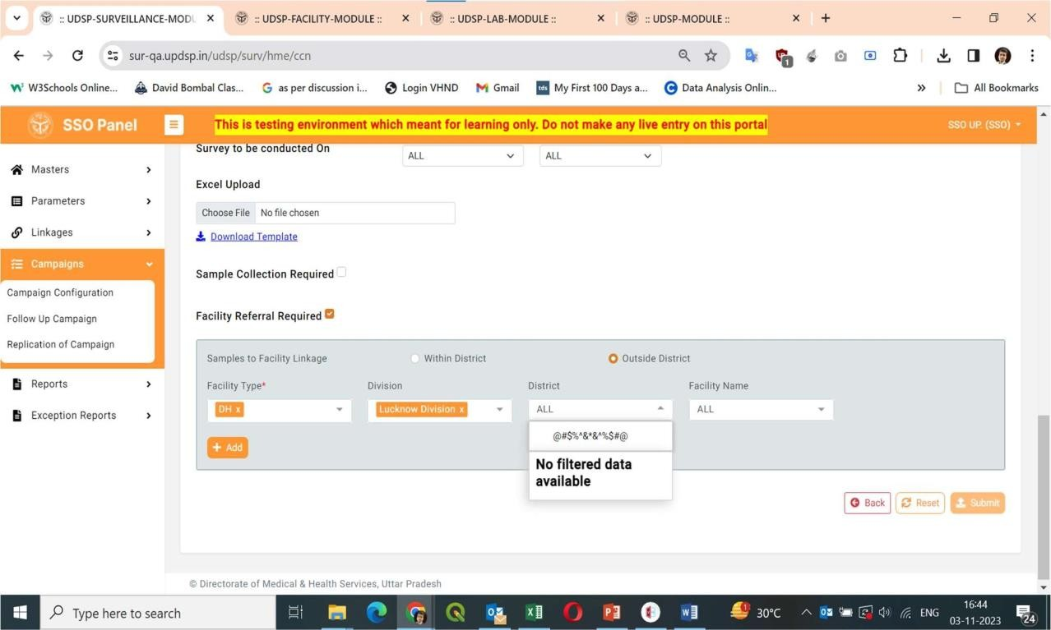

➔ What exactly the issue is.! Because the text has been wrapped up below format post acceptance from Vishan only

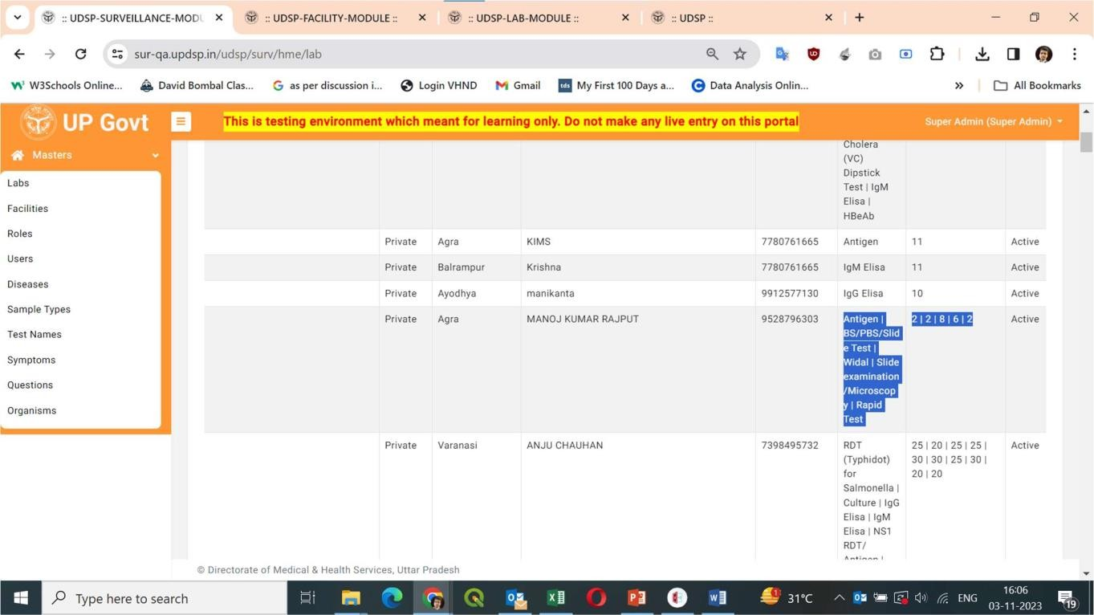

Slide no. 5: The Arrow Key and Side cut at dropdown.

➔ **working on dropdown fix**

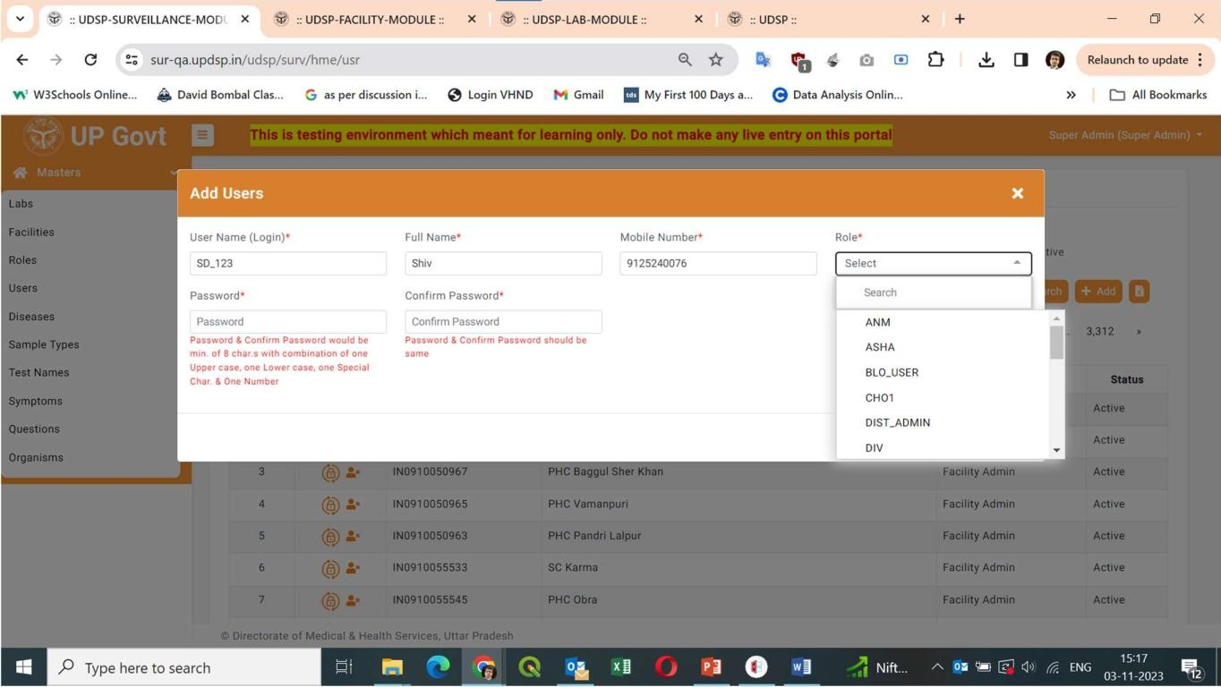

➔ **As instructed from clients, we applied freezing of headers in specified report screens only**

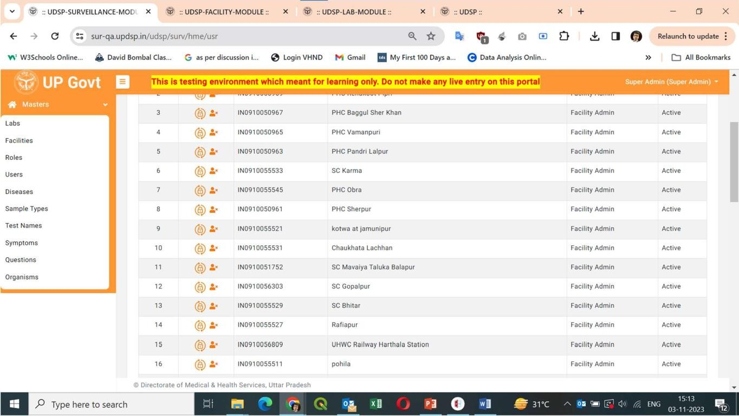

Slide no. 7: Testing in progress. Slide no. 8: Not resolved.

➔ As commented & informed earlier, the dropdown fields behaves that way only

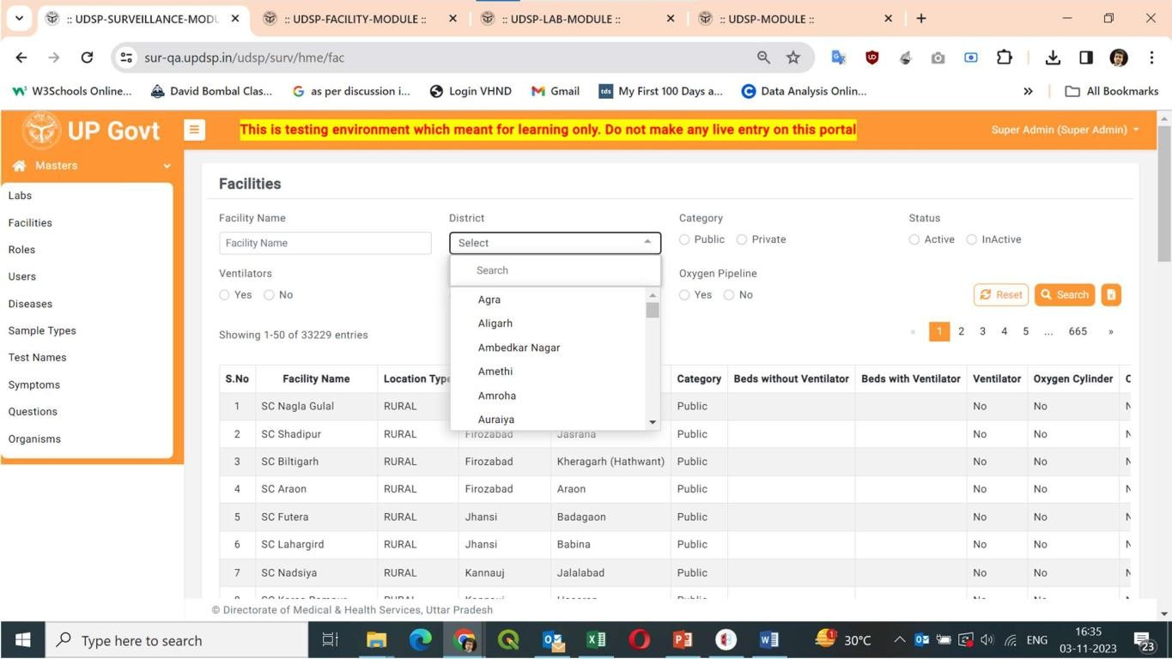

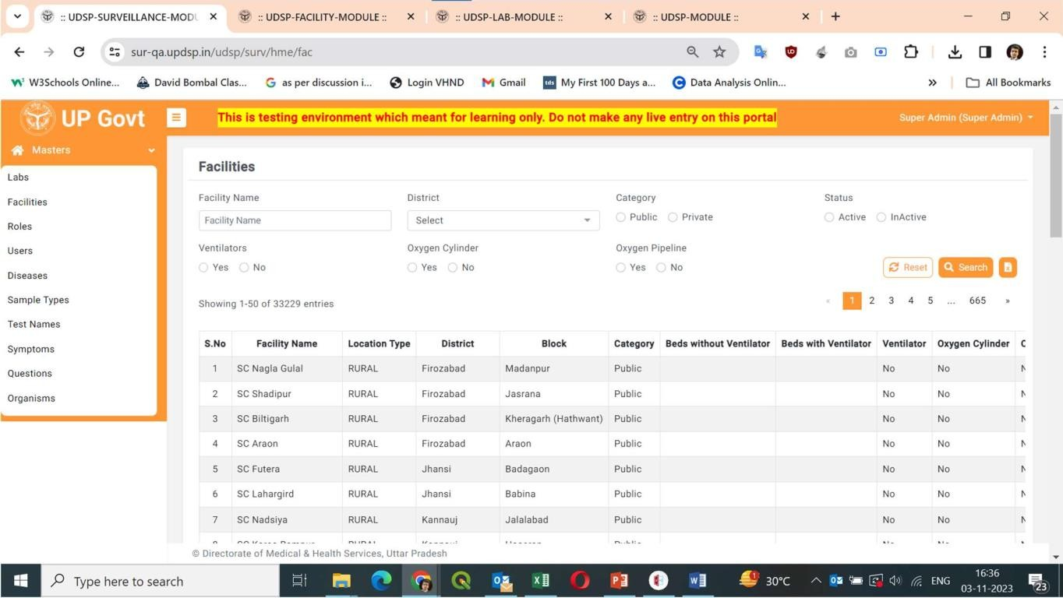➔ Kindly tell us, what need to be shown instead of UP Govt. icon for Super Admin user

Slide no. 10: Done

Slide no. 11: Not resolved.

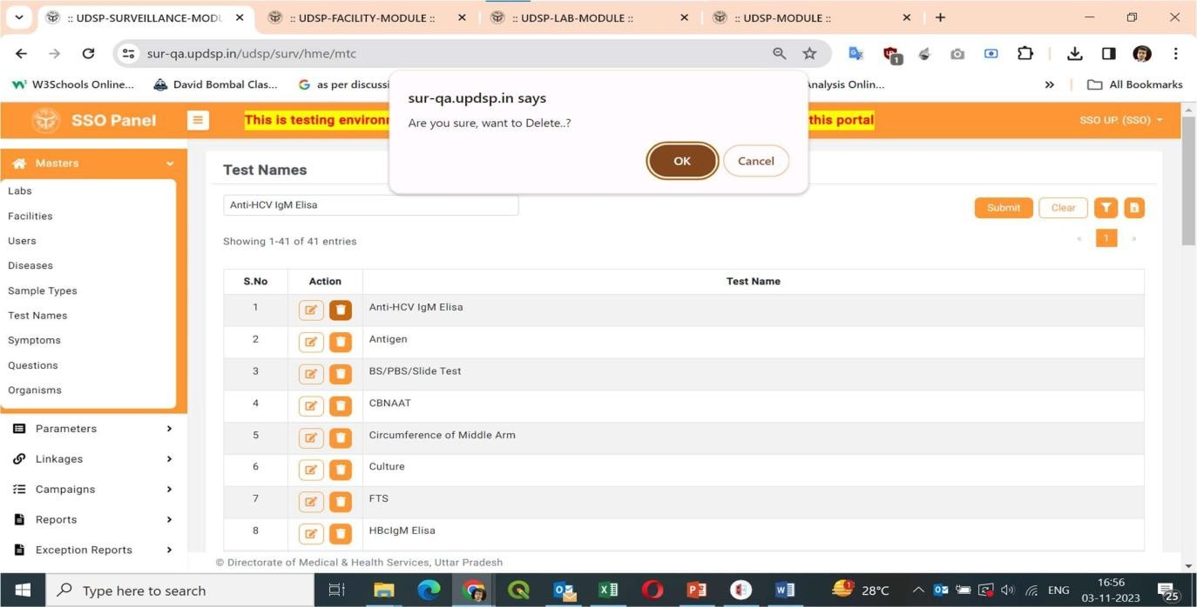➔ As logged over the slide, we’re completed in Users screen, now they are raised the same in Test Names’ screen

Slide no. 13: Exception should be in red. Please refer ppt for actual observation.

➔issue fixed

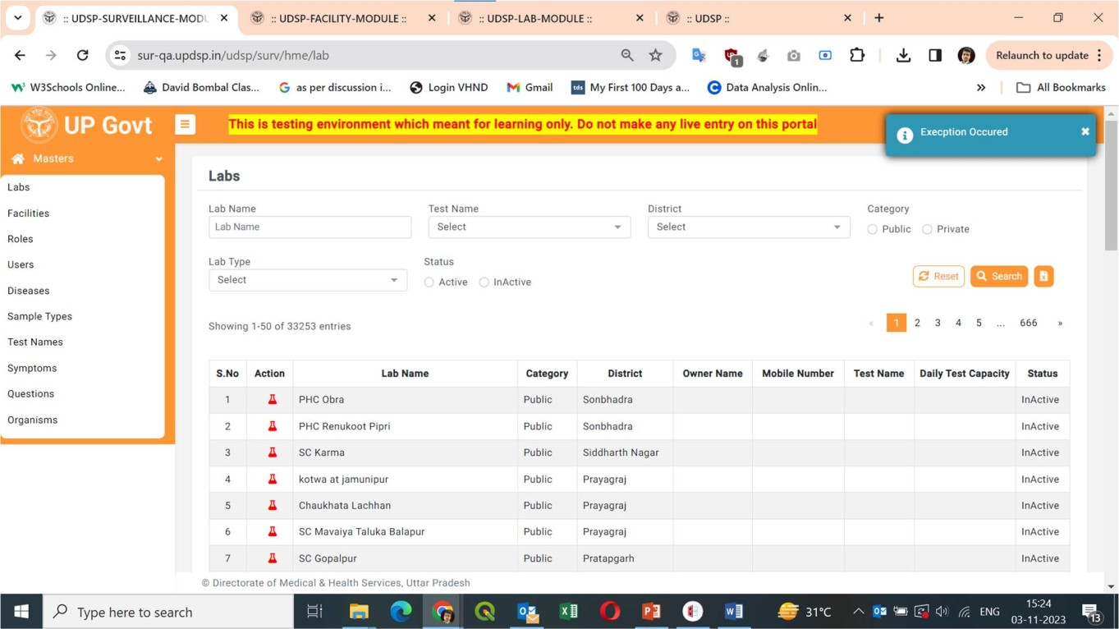

Slide no. 14: Error occurred while adding a new patient so it can’t be tested.

➔ issue fixed

